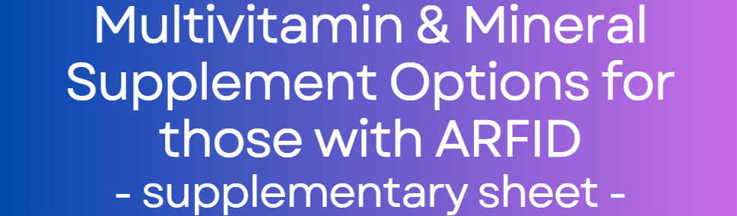

About this resource

This is a blank supplementary resource intended to support the original resource titled: ‘Multi Vitamin and Mineral Advice and Options for those with ARFID’. It is intended as a tool for dietitians to collate and add further frequently used multi-vitamin and mineral preparations which may be more specific to their care setting.

To use the tool:
- Add the name of the preparation in the first column, under the correctly corresponding sensory preparation
- Add the age range into the second column
- Add an X to indicate whether the supplement is suitable for vegetarians or vegans
- Add an X into each micronutrient box that the supplement contains
- Add a flavour in the end column by using the flavour key (final page)

The table then shows you at quick glance which micronutrient preparation may be suitable for your patients’ needs. The tool is not able to specify the appropriate age range, %DRV, or the necessary dose.

SPRINKLES | Age | Ve | Veg | B1 | B2 | B3 | B5 | B6 | B7 | B12 | D | C | A | E | K | Na | K+ | Iron | Folate | Folic | Cal | Zinc | Cu | Mg | Phos | Sel | Iodine | Chl | Mang | Moly | Chr | L.ly | Flavour
POWDER | Age | Ve | Veg | B1 | B2 | B3 | B5 | B6 | B7 | B12 | D | C | A | E | K | Na | K+ | Iron | Folate | Folic | Cal | Zinc | Cu | Mg | Phos | Sel | Iodine | Chl | Mang | Moly | Chr | L.ly | Flav
DROPS | Age | Ve | Veg | B1 | B2 | B3 | B5 | B6 | B7 | B12 | D | C | A | E | K | Na | K+ | Iron | Folate | Folic | Cal | Zinc | Cu | Mg | Phos | Sel | Iodine | Chl | Mang | Moly | Chr | L.ly | Flav
LIQUID / SYRUP | Age | Ve | Veg | B1 | B2 | B3 | B5 | B6 | B7 | B12 | D | C | A | E | K | Na | K+ | Iron | Folate | Folic | Cal | Zinc | Cu | Mg | Phos | Sel | Iodine | Chl | Mang | Moly | Chr | L.ly | Flav.
GUMMY | Age | Ve | Veg | B1 | B2 | B3 | B5 | B6 | B7 | B12 | D | C | A | E | K | Na | K+ | Iron | Folate | Folic | Cal | Zinc | Cu | Mg | Phos | Sel | Iodine | Chl | Mang | Moly | Chr | L.ly | Flav
CHEWY | Age | Ve | Veg | B1 | B2 | B3 | B5 | B6 | B7 | B12 | D | C | A | E | K | Na | K+ | Iron | Folate | Folic | Cal | Zinc | Cu | Mg | Phos | Sel | Iodine | Chl | Mang | Moly | Chr | L.ly | Flav
TABLET | Age | Ve | Veg | B1 | B2 | B3 | B5 | B6 | B7 | B12 | D | C | A | E | K | Na | K+ | Iron | Folate | Folic | Cal | Zinc | Cu | Mg | Phos | Sel | Iodine | Chl | Mang | Moly | Chr | L.ly | Flav
EFFERVESCENT | Age | Ve | Veg | B1 | B2 | B3 | B5 | B6 | B7 | B12 | D | C | A | E | K | Na | K+ | Iron | Folate | Folic | Cal | Zinc | Cu | Mg | Phos | Sel | Iodine | Chl | Mang | Moly | Chr | L.ly | Flav
SPRAY | Age | Ve | Veg | B1 | B2 | B3 | B5 | B6 | B7 | B12 | D | C | A | E | K | Na | K+ | Iron | Folate | Folic | Cal | Zinc | Cu | Mg | Phos | Sel | Iodine | Chl | Mang | Moly | Chr | L.ly | Flav

Table Key
Age | A - Adult 18 years and above  Number- Age in years e.g. 12y+ represents 12 years and over  Months- Age in months e.g. 3m+ represents 3months and over
Ve | Vegan
Veg | Vegetarian
B1 | Vitamin B1 (Thiamine)
B2 | Vitamin B2 (Riboflavin)
B3 | Vitamin B3 (Niacin)
B5 | Vitamin B5 (Pantothenic Acid)
B6 | Vitamin B6 (Pyridoxine)
B7 | Vitamin B7 (Biotin)
B12 | Vitamin B12 (Cobalamin)
D | Vitamin D
C | Vitamin C
A | Vitamin A
E | Vitamin E
K | Vitamin K
Na | Sodium
K+ | Potassium
Iron | Iron
Folate | Folate
Folic | Folic Acid
Cal | Calcium
Zinc | Zinc
Cu | Copper
Mg | Magnesium
Phos | Phosphorus
Sel | Selenium
Iodine | Iodine
Chl | Chlorine
Mang | Manganese
Moly | Molybdenum
Chr | Chromium
L.ly | L. Lysine
Flavours Key
AB | Apple and Blackcurrant
Bl | Blueberry
BP | Blackcurrant and Plum
Br | Berry
C | Cherry
CM | Chocolate and Marshmallow
F | Fruit
G | Grape
O | Orange
P | Peppermint
PA | Pineapple
PO | Pomegranate
PR | Pomegranate and Raspberry
R | Raspberry
SM | Strawberry Milkshake
Tr | Tropical
U | Unflavoured

