Weight management in learning disabilities: A project exploring the views of individuals with a learning disability and an evaluation of the evidence base.
Author: Jessica Lockley Mentor: Rose Dewey Start Date: March 2022

Accessible Summary
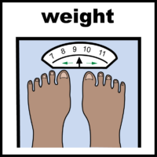
This report is about what can be done to help people with a learning disability manage their weight.

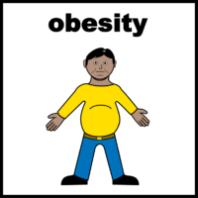
There are more people with a learning disability who are very overweight (obese) than people without a learning disability.


In this report there is:

- Information from research looking at what has been tried before

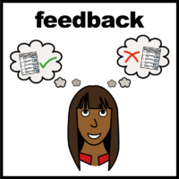
- Information from feedback sessions with people with a learning disability


There are also some recommendations for what work needs to be done in the future such as:

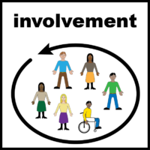
- More research about this issue

- Involving people with a learning disability in planning for services and in research


- Different teams across Leeds working together to make sure services are suitable for people with a learning disability

Introduction
The problem this report is seeking to explore and address is the levels of overweight/obesity in individuals with a learning disability (LD).
Background
The Obesity Profile from NHS Digital shows data indicating that 63.5% of adults (age 18+) were classified as overweight or obese in 2020/2021. Locally, 63.6% of adults were classified as overweight and obese in Leeds (just above the England average). Overweight and obesity is associated with an increased risk of several chronic diseases such as type 2 diabetes, cancer and cardiovascular disease (Guh et al., 2009).
In terms of individuals with a learning disability living with overweight/obesity, data taken from NHS Digital suggests that levels of obesity are much higher in the LD population than in those without an LD (Figure 1).

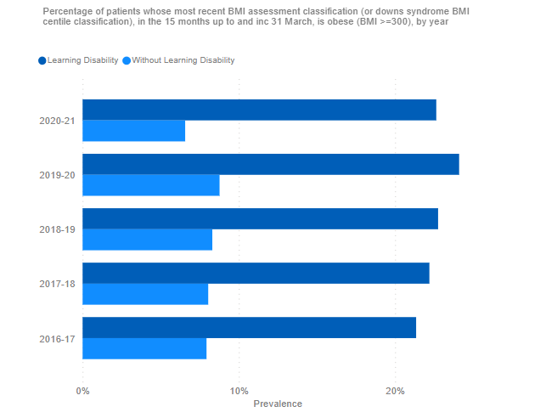
Figure 1

The 2021 Learning from Lives and Deaths of people with a Learning Disability and Autistic people (LeDer) report found that 6 out of 10 people with a learning disability died before they were 65 and that on average, males with a learning disability die 22 years younger than males from the general population, and females 26 years younger– highlighting the stark inequalities experienced by this population group and the importance of reducing inequalities relating to overweight/obesity and its associated comorbidities. The recent Covid-19 pandemic brought these inequalities to the forefront as the 2020 LeDer report found that adults who died from COVID-19 were more likely to be obese compared to adults who died from other causes.
Weight management is a complex problem, the Foresight report (2007) highlighted the multitude of factors influencing obesity and the LD population face additional barriers, these include: anti-psychotic medications; individuals’ and carers’ lack of knowledge, food used to reduce challenging behaviours, mobility problems causing reduced physical activity and having the capacity to make decisions related to food.
Locally, the majority of service users referred to the Community Learning Disability dietetic team are for weight management, however, the small dietetic resource is often unable to meet the need, leading to a long waiting list. Whilst awaiting dietetics, there is often further weight gain and development of other co-morbidities such as diabetes and cardiovascular disease, shortening their life expectancy. Prior to this, service users may have tried or been unable to access mainstream weight management services such as One You Leeds or commercial groups. More recently, One You Leeds have announced they will no longer be providing Tier 2 weight management services in Leeds, leading to a gap in service provision until a new weight management service is established, further increasing the risks for the LD population.
In terms of guidance available for professionals or services working in weight management with individuals with an LD, NICE guidance (2014, updated September 2022) advises the following:
- to assess the role of family and care workers in supporting individuals with a learning disability to make lifestyle changes
- to consider referral to tier 3 services for those with additional support needs such as people with learning disabilities
- To consider the persons specific communication needs
Public Health England (2018) also produced some guidance regarding obesity and weight management for people with learning disabilities which discusses the challenges of assessing a healthy weight e.g. due to wheelchair use and limitations of BMI in those with atypical body shapes. The guidance emphasises the importance of the following:
- Raising awareness of excess weight with people with learning disabilities and their family/carers
- Annual health checks
- The role of families and social care staff
- Ensuring mainstream services are accessible
- Environmental, social and personal factors
- Capacity and choice around diet and physical activity

Aims
The initial aims of this project are two-fold: 1) to examine the evidence base surrounding weight management interventions in individuals with a learning disability 2) to speak to individuals with a learning disability to explore their views and ideas on this topic. It is envisaged that by delving deeper into this topic through the Health Equity Fellowship, recommendations for future practice will follow. The desired result of the project would be further insight into how services can better support this population group to manage their weight and reduce the risk of obesity related comorbidities and earlier mortality.

Theory of change
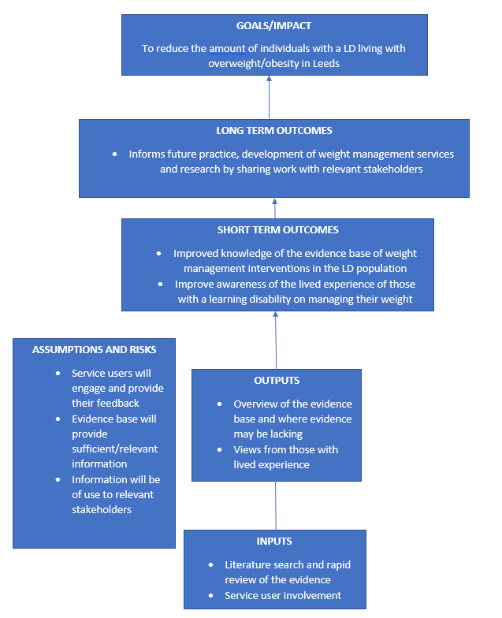

Literature search
Given the timeframe of the fellowship, a rapid review of the literature was conducted based on the guidance from ‘A rapid review guidebook’ from the National Collaborating Centre for Methods and Tools.
The first step was identifying a question: the following information was provided to Leeds and York Partnership NHS Foundation Trust library services:
Evidence requested around ‘weight management/weight loss interventions/obesity interventions in adults with a learning disability/ intellectual disability’
This fits the PICO framework of defining a practice question (Figure 2), however, on reflection, this practice question could have been clearer and a comparator of individuals without a learning disability could have been provided, for example, a more refined question could have asked: What is the impact of weight management interventions on weight loss, among adults with an intellectual/learning disability, in comparison to those without a learning disability?
Population of interest = Learning disabilities/Intellectual disability
Interventions and/or Exposure (risk factor) = Weight management/obesity interventions
Comparator = ?individuals without an LD
Outcome = weight loss
Figure 2

The following databases were searched:
- BNI: A UK focused database that covers nursing
- CINAHL: A large US database covering all aspects of nursing and allied health
- Embase: With particular emphasis on European sources, this database covers the whole field of medicine
- Medline: A very large US database of medical information
A combination of thesaurus terms and free-text was used for the search.
A tool from Health Evidence (2009) was utilised to help with keeping on track with search results and Figure 3 depicts the search process that took place.
Figure 3

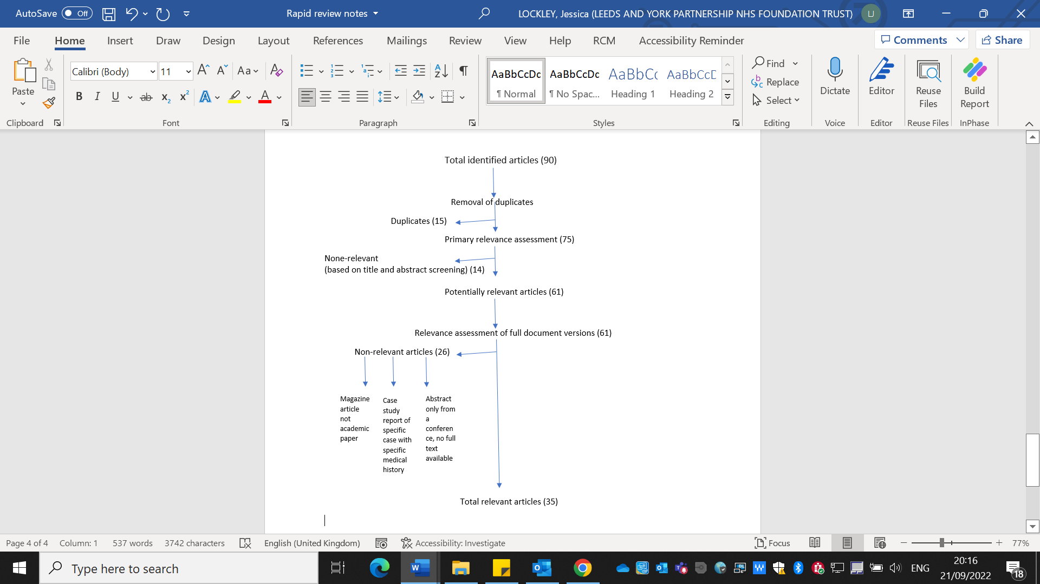
Figure 3

Data extraction and critical appraisal
Appendix 1 outlines the information gathered during the data extraction phase of the 35 relevant papers identified.
Summary of findings from literature review
Of the 35 relevant papers, the following types of studies were identified:
- 4 randomised controlled trials (RCT) were identified (including a RCT feasibility study) and 5 secondary analysis studies of the RCTs.
- 5 study protocols
- 5 systematic/integrative (also includes qualitative studies) reviews with/without meta-analysis
- 1 narrative review
- 8 qualitative analysis studies (6 of which included the views/experiences of individuals with an LD).
- 7 quasi experimental/pilot or feasibility/single stranded studies
A summary of the evidence has been provided below, focusing on systematic and integrative reviews and randomised controlled trials due to these being higher quality levels of evidence (Essential Evidence Plus, 2019). Further details of all studies identified can be found in Appendix 1.
Summary of integrative/systematic reviews
Type of paper | Name / authors | Number of studies | Key outcomes | Strengths | Weaknesses
Systematic review | Salse-Batán et al., 2022 - Effects of exercise training on obesity‐related parameters in people with intellectual disabilities: systematic review and meta‐analysis | 19 in qualitative and 17 in quantitative (adults and children). | 14 of the studies reported on body weight measurements and only 3 of these reported an average weight loss superior to -3%. Meta analysis for body weight, BMI, fat mass and waist circumference showed no significant results for any of the types of exercise interventions examined. | Paper is recent. Search process included research published in English, French, Portuguese or Spanish and study authors contacted for missing data. | Not all of the studies included informed on aetiology and severity of LD, a high proportion of the studies focussed on participants with down syndrome and there was differing measures used to assess outcomes.
Systematic review and meta-analysis | Harris et al., 2018 - The effects of multi-component weight management interventions on weight loss in adults with intellectual disabilities and obesity: A systematic review and meta-analysis of randomised controlled trials | 6 randomised controlled trials | Average intervention length was 4.5 months. Studies differed in terms of their level of carer involvement (2 studies did not include any carer involvement). Majority of studies focused on a health education approach and physical activity interventions varied across studies. Only 1 study had a weight maintenance period which was 5 weeks. The meta-analysis found that current multi-component weight management interventions are not more effective than no treatment, however, the authors appear to mainly attribute this to the studies not adhering to clinical guidance re including an energy deficit diet and focussing more on a health promotion. | Clearly focussed question. RCTs only included in review. | 50% of studies included had insufficient info to judge risk of bias. All participants had mild-moderate LD.
Systematic review | Spanos et al., 2013 - Weight management interventions in adults with intellectual disabilities and obesity: A systematic review of the evidence. | 22 studies | Most studies were uncontrolled or single stranded studies and only 8 used a multi-component approach. A lack of information on the role of carers in interventions was found. Only 4 out of the 22 studies included a weight maintenance period. 3 studies reported clinically significant weight loss within 6 months (1 behaviour change and physical activity and 2 multicomponent), other studies reported clinically significant weight loss at 9 months and 12 months, however, authors comment that limitations and differences in methodology do now allow comparisons or support of effectiveness of the studies. | Assessment of quality of studies included based on checklist developed (however, lack of detail re this in the study). | Review not restricted to RCTs. Small sample sizes of studies included. Heterogenous sample in terms of level of ID and body weight making it hard to compare studies. 9 years old.
Integrative review - An integrative review of multicomponent weight management interventions for adults with intellectual disabilities. | Doherty et al., 2017 | 5 studies | 2 studies reported clinically significant weight loss outcomes in those with ID who had obese BMI. One study explored views and experiences of 24 carers of participants with ID, 1 explored views and experiences of 17 health care practitioners involved in the delivery of multicomponent intervention to adults with ID. Common findings were lack of support for individuals with ID, poor communication as barriers, role of supportive carers emphasised alongside need for motivation amongst all participants, carers, healthcare practitioners. | Integrative review to assess both clinical effectiveness and views of participants/carers/ health care professionals. Thorough assessment of quality of studies undertaken. | Heterogenous sample in terms of body weight making it difficult to compare results. Some studies excluded due to insufficient information. Review limited to English language studies. 5 years old.

Summary from randomised controlled trials:
Type of paper | Name / authors | Intervention | Number of participants | Key outcomes | Strengths | Weaknesses
Randomised controlled feasibility trial | Lally et al., 2021 - A manualised weight management programme for adults with mild–moderate intellectual disabilities affected by excess weight: A randomised controlled feasibility trial (Shape Up‐LD)* | 3-month active intervention, 3 month follow up. Shape up LD weight management group sessions vs. usual care. Shape up-LD manualised healthy lifestyle programme, groups of 4-6, met once per week for 3 months. Sessions lasted 120 mins. Delivered by 2 members of staff. 4 introduction sessions, 8 sessions based on healthy eating and physical activity. Usual care had short (approx. 30 mins) discussion with researcher re healthy eating and physical activity and were provided with a leaflet and DVD. | 50 | Individuals with mild-moderate LD with overweight/obesity. Follow up rates 78% at 3 months and 74% at 6 months. 30% of participants attended without a carer, for 35% a carer only attended some of the sessions. Did not find any statistically significant results in anthropometric measures, however, there was a trend towards maintenance in the intervention group at 3 and 6 months and a trend towards weight gain in the control group. Waist circumference results do not fit with changes in bodyweight and body fat and authors commented this is likely due to difficulty obtaining this measurement from participants. | Allocation concealment and measurements administered by researcher blinded to group allocation. Intention to treat approach used. | Limited outcomes measured due to being feasibility trial. Included those with mild-moderate LD only. Short time frame.
Randomised controlled trial | Neumeier et. al 2021 - POWERSforID: Personalized online weight and exercise response system for individuals with intellectual disability: A randomized controlled trial. | Individuals with mild-moderate LD and obese BMI, accessing clinic specialising in LD recruited for study. Randomised to control or intervention. Both groups asked to attend at weeks 1, 12 and 24. Control group included consultation with medical professional and discussion re health strategies with health coach. Intervention group also had access to additional materials and weight management assistance through PowersforID platform and extra calls with health coach. | Intervention = 17  Control = 18 | Found a statistically significant reduction in weight in the intervention group, however, the 2.7% weight loss was not clinically meaningful (defined as between 5-10% weight loss). Reduction in body weight, waist circumference and BMI in control group but not statistically significant | Research staff blinded. Intent to treat analysis took place. | Small sample size. Included participants with mild-moderate LD only. Short intervention time frame to assess long term changes to weight.
Randomised controlled trial | Ptomey et al., 2017 - Weight management in adults with intellectual and developmental disabilities: A randomized controlled trial of two dietary approaches | Recruited those with mild-moderate LD with overweight or obese BMI. 6-month weight loss, 12-month maintenance period. Enhanced stop light diet (eSLD) (intervention) vs. conventional diet. eSLD involved: 2 portion-controlled entrees/day, 2 portion controlled shakes/day, 5 one-cup servings of fruit and veg/day, Ad libitum non-caloric beverages and additional meals and snacks selected using the stop light diet guide. Conventional diet involved: 500-700kcal deficit, provided recommended servings on fruit, veg, grains, dairy and protein to meet energy intake goals, info re appropriate serving sizes of food items and measuring foods to ensure compliance with serving size recommendations. All participants had a study partner. | 150 | Weight loss, BMI and waist circumference was greater in eSLD group. The proportion of participants achieving weight loss of >5% among participants completing the 6-month weight loss intervention was greater in the eSLD (62.3%,) compared with the CD group (40.4%). Between group differences in weight maintenance (7-18 months) was not statistically significant and weight loss at 18 months did not differ significantly between 2 groups. | Allocation concealment, stratified by number of adults in a residence. Research assistants blinded. | Larger scale sample size (compared to other RCTs). Mild-moderate LD only. Participants provided with financial incentives (had the potential to receive ~$560) for taking part – limiting the reproducibility and ?how much this impacted results.
Cluster randomised controlled trial | Harris et al., 2017 - A cluster randomised control trial of a multi-component weight management programme for adults with intellectual disabilities and obesity | Participants randomised to either Take 5 or Waist Winners Too (WWToo). 12-month intervention - 6 month weight loss 6 month weight maintenance. 9-12 sessions for weight loss phase, 6 sessions for weight maintenance phase. Take 5 incorporated energy deficit diet whereas WWToo was a health education programme. Both programmes included physical activity and behaviour change techniques. | Intervention = 26  Control = 24 | Based on ITT, no significant between group effect on change in body weight post programme from baseline, however, within group change in body weight at 12 months showed significant programme effect for TAKE 5 but not WWToo. At 12 months, there was a trend for more participants in the TAKE 5 programme (50·0 %) to achieve a clinically important weight loss than the comparator programme (20.85) (but this wasn’t statistically significant). During the weight maintenance phase, the majority of participants in both programmes maintained their weight (58·3 %, 68·2 %, TAKE 5 and WWToo, respectively) within ±2·99 % of initial body weight. | Included participants with a range of severity of LD. Intention to treat analysis. Cluster randomisation to minimise risk of contamination between programmes | Did not recruit amount of participants needed from power calculation.

Service user involvement
Development of resources and recruitment
The service user involvement element of this project was completed in collaboration with the service user involvement team at Leeds and York Partnership Foundation Trust (LYPFT).
The main target audience were individuals with a learning disability who have tried to manage their weight – either with help from mainstream, commercial or specialist services as well as those who had not had any help to lose weight. The rationale for targeting individuals with differing experiences of weight management was to ensure that a wide variety of experiences were captured, and to assess how experiences may have differed depending on what help someone had received. By finding out what services individuals had accessed and their experience, it was felt this would provide insight into how services can improve their practice.
Project information, flyers and consent forms were developed in collaboration with the service user involvement team. See Appendix 2 for these documents.
A ‘weight management conversation tool’ (Figure 4) was developed which was to be completed during the feedback sessions.
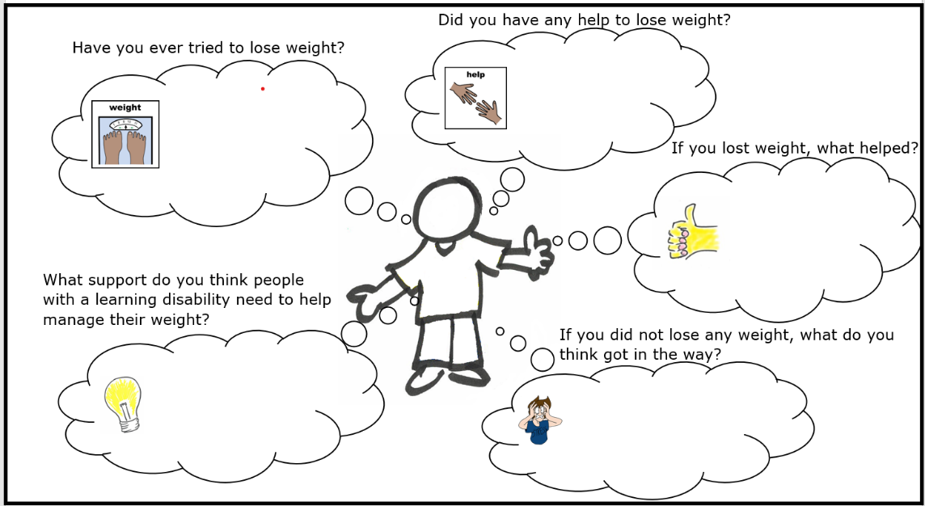
Figure 4

All the documents produced were reviewed by the service user involvement team to ensure that these were Easy Read and accessible, as per the NHS England Accessible Information Standard (2016).
The project information and flyer were shared by the service user involvement team with their networks with the aim of recruiting participants. The information was also shared in the Community Learning Disability Team multi-disciplinary meeting and it was requested that professionals share with individuals who they thought may be interested in taking part.
A risk assessment was also undertaken by the author to ensure safe lone working practices.
Outcomes
3 participants took part in the feedback sessions. 1 feedback session took place virtually over Microsoft Teams and 2 took place at a LYPFT site. The project information was discussed at the start of the sessions to ensure that all participants understood the reason for the feedback sessions and could ask any questions or change their mind about participating. All provided either verbal or written consent. The information gathered in these sessions in displayed in Appendix 3, 4 and 5 (no confidential information is included in this information).
1 of the participants hadn’t received any help from any services to manage their weight and the 2 other participants were both currently accessing a commercial weight management service.
Due to the small number of participants and the fact that this was not a qualitative research study, there are limitations on what conclusions can be drawn from the information gathered, however, the main themes from the participant’s feedback are summarised below.
Similar themes:
- All participants indicated that they had tried to lose weight before as well as trying to do so currently
- When discussing what helped them to lose weight:
  - 2 participants referenced increased physical activity e.g. ‘going to the gym’ and ‘more walking’
  - 2 participants referenced changing their eating e.g. ‘learning about portion sizes’, ‘not eating so much’, ‘eating more fruit’
- When discussing what got in the way of losing weight:
  - All 3 participants referenced lack of accessible information e.g. ‘information being long-winded with jargon’ and ‘not being able to take it all in (the advice)’
  - All 3 mentioned food e.g. advertising of Mcdonalds (in the media), ‘buying wrong foods such as cream cakes’, ‘I’ve got a very sweet tooth and like crisps’
- When discussing what support they think people with a learning disability need to help manage their weight:
  - All 3 participants referenced help from professionals e.g. ‘think people need to be referred for help’, ‘going to their doctor or hospital’, ‘health care professionals to provide more information’.
  - 2 participants referenced peer to peer support e.g. ‘getting help from a friend’, ‘peer to peer support from somebody who has lost weight before’

To ensure all the information is captured, the ideas for ‘what support do you think people with a learning disability need to manage their weight’ are summarised below (the words used by the participants have been used as closely as possible):
- Support workers or family to encourage, support, help with reading food labels and cooking
- Easy read accessible information on losing weight such as a book with pictures and writing
- Health care professionals to provide more information and to work with the person to come up with an action plan and set goals, working together, and checking how they are getting on with the plan
- Mental support as losing weight can be a lot of pressure, someone to talk to if finding it hard e.g. family/healthcare/friends
- Someone to talk to when the willpower is going away as this can make you feel stressed out
- Role models – more public speaking from people with a learning disability who have lost weight to change people’s attitude about how to lose weight and to reduce bullying of people who are overweight e.g. in schools.
- Peer to peer support from somebody who has lost weight
- Eating healthy
- Getting weighed
- Going to their doctor or hospital
- More accessible information
- Getting help from a friend such as going to Slimming World together so you can help each other and chat on the way there
- Think people need to be referred for help such as to a dietitian or Slimming World
- Need help to do more exercise such as swimming e.g. a physiotherapist to show what to do in the pool

Conclusion
To conclude this report, I will summarise my main reflections and recommendations for future practice.
Reflection on literature search findings
- Most studies in the review are at least 3 years old, with just under half being 5 years old, highlighting the lack of current research in this area.
- There is a lack of good quality evidence – including a lack of randomised controlled trials and systematic reviews.
- Most of the research focuses on individuals with a mild-moderate learning disability and there appears to be a lack of evidence in those with more severe and profound LD with regards to weight management. There is also a lack of discussion in the literature about how interventions may need to vary depending on the level of LD.
- All RCT’s included incorporate physical activity and some have an inclusion criterion that states the person must be ambulatory. This limits the generalizability of the findings as many with a learning disability also have physical disabilities which will limit their ability to engage in generic physical activity advice.
- Despite NICE guidance advising the importance of developing skills for weight maintenance there was a lack of weight maintenance interventions in studies and studies were typically short in duration.
- Only 6 qualitative studies were found which included the views/lived experiences of those with an LD, highlighting the lack of co-production and service user involvement in the research in this area.
- Weight and BMI were often used as primary outcome measures, however, as discussed by Public Health England (2018), it can be difficult for all the LD population to accurately have this measured and this did not appear to be widely acknowledged or discussed in the literature.
- The Mental Capacity Act (2005) and individuals’ capacity around dietary choices is rarely mentioned in the literature.
- Lastly, it must be acknowledged that as this was a rapid review, the search strategy may have limited the studies found and due to the timescale of the project, I was unable to read other papers that were identified in the reference list of other studies, which may have given a more thorough picture of the current evidence base.
Reflection on service user feedback sessions
- It would have been beneficial to interview a larger number of service users with a wider variety of experiences e.g. experience of input from specialist services, to see if this would provide any further insight in to ways we can improve practice moving forward.
- This project has provided further evidence of how it is possible to involve service users in projects – the research community and those working with service users with a learning disability around managing their weight should aim to involve the views of individuals with an LD.
- The community learning disability dietitians do not currently involve service users in our pathway and resource development; therefore, this should be considered in future.
Recommendation for future practice
- The community learning disability dietetics team to employ a co-production approach to future weight management pathway/resource development
- Further research should be conducted in weight management and learning disabilities – for healthcare professionals such as LD dietitians to contribute to the evidence base.
- Further research should be conducted involving those with a lived experience of a learning disability and across a wider range of severity of learning disabilities.
- Joint working across the stakeholders in Leeds who may support individuals with a learning disability to manage their weight, ensuring that the LD population are fully represented in the new weight management model that is currently being developed for Leeds.

References
Chapman, M.J., Craven, M.J. and Chadwick, D.D. (2005). Fighting fit? Journal of Intellectual Disabilities, 9(2), pp.131–144. doi:10.1177/1744629505053926.

Chapman, M.J., Craven, M.J. and Chadwick, D.D. (2008). Following up Fighting Fit. Journal of Intellectual Disabilities, 12(4), pp.309–323. doi:10.1177/1744629508100557.

Croot, L., Rimmer, M., Salway, S., Hatton, C., Dowse, E., Lavin, J., Bennett, S.E., Harris, J. and O’Cathain, A. (2018). Adjusting a mainstream weight management intervention for people with intellectual disabilities: a user centred approach. International Journal for Equity in Health, 17(1). doi:10.1186/s12939-018-0871-4.

Doherty, A.J., Jones, S.P., Chauhan, U. and Gibson, J.M.E. (2017). An integrative review of multicomponent weight management interventions for adults with intellectual disabilities. Journal of Applied Research in Intellectual Disabilities, 31, pp.39–51. doi:10.1111/jar.12367.

Doherty, A., Jones, S., Chauhan, U. and Gibson, J. (2018). Eating well, living well and weight management: A co-produced semi-qualitative study of barriers and facilitators experienced by adults with intellectual disabilities. Journal of Intellectual Disabilities, p.174462951877393. doi:10.1177/1744629518773938.

Doherty, A.J., Jones, S.P., Chauhan, U. and Gibson, J.M.E. (2019). Healthcare practitioners’ views and experiences of barriers and facilitators to weight management interventions for adults with intellectual disabilities. Journal of Applied Research in Intellectual Disabilities. doi:10.1111/jar.12596.

Donnelly, J.E., Saunders, R.R., Saunders, M., Washburn, R.A., Sullivan, D.K., Gibson, C.A., Ptomey, L.T., Goetz, J.R., Honas, J.J., Betts, J.L., Rondon, M.R., Smith, B.K. and Mayo, M.S. (2013). Weight management for individuals with intellectual and developmental disabilities: Rationale and design for an 18month randomized trial. Contemporary Clinical Trials, 36(1), pp.116–124.
doi:10.1016/j.cct.2013.06.007.

Essentialevidenceplus.com. (2019). EBM: Levels of Evidence - Essential Evidence Plus. [online] Available at: https://www.essentialevidenceplus.com/product/ebm_loe.cfm?show=oxford.
fingertips.phe.org.uk. (n.d.). Obesity Profile - Data - OHID. [online] Available at: https://fingertips.phe.org.uk/profile/national-child-measurement-programme/data#page/4/gid/1938133368/pat/6/ati/401/are/E08000035/iid/93088/age/168/sex/4/cat/-1/ctp/-1/yrr/1/cid/4/tbm/1 [Accessed 10 Nov. 2022].

Griffin, M. (2009). Demonstrating the well‐being benefits of a weight loss programme for people with a learning disability. Journal of Public Mental Health, [online] 8(1), pp.32–36. Available at: http://repository.essex.ac.uk/2317/ [Accessed 11 Nov. 2022].

Guerra, N., Neumeier, W.H., Breslin, L., Geer, B., Thirumalai, M., Ervin, D.A. and Rimmer, J.H. (2019). Feedback and Strategies From People With Intellectual Disability Completing a Personalized Online Weight Loss Intervention: A Qualitative Analysis. Intellectual and Developmental Disabilities, 57(6), pp.527–544. doi:10.1352/1934-9556-57.6.527.

Guh, D.P., Zhang, W., Bansback, N., Amarsi, Z., Birmingham, C.L. and Anis, A.H. (2009). The incidence of co-morbidities related to obesity and overweight: A systematic review and meta-analysis. BMC Public Health, [online] 9(1). doi:10.1186/1471-2458-9-88.

Hamilton, S., Hankey, C.R., Miller, S., Boyle, S. and Melville, C.A. (2007). A review of weight loss interventions for adults with intellectual disabilities. Obesity Reviews, 8(4), pp.339–345. doi:10.1111/j.1467-789x.2006.00307.x.

Harris, L., Hankey, C., Jones, N., Murray, H., Pert, C., Tobin, J., Boyle, S., Shearer, R. and Melville, C.A. (2018). Process evaluation of a cluster‐randomised controlled trial of multi‐component weight management programme in adults with intellectual disabilities and obesity. Journal of Intellectual Disability Research, 63(1), pp.49–63. doi:10.1111/jir.12563.

Harris, L., Hankey, C., Jones, N., Pert, C., Murray, H., Tobin, J., Boyle, S. and Melville, C. (2017). A cluster randomised control trial of a multi-component weight management programme for adults with intellectual disabilities and obesity. British Journal of Nutrition, [online] 118(3), pp.229–240. doi:10.1017/s0007114517001933.

Harris, L., Melville, C., Jones, N., Pert, C., Boyle, S., Murray, H., Tobin, J., Gray, F. and Hankey, C. (2015). A single-blind, pilot randomised trial of a weight management intervention for adults with intellectual disabilities and obesity: study protocol. Pilot and Feasibility Studies, 1(1). doi:10.1186/2055-5784-1-5.

Harris, L., Melville, C., Murray, H. and Hankey, C. (2018). The effects of multi-component weight management interventions on weight loss in adults with intellectual disabilities and obesity: A systematic review and meta-analysis of randomised controlled trials. Research in Developmental Disabilities, 72, pp.42–55. doi:10.1016/j.ridd.2017.10.021.

Health-evidence.ca. (2009, November 25). Keeping Track of Search Results: A Flowchart. Retrieved [insert date you downloaded this document e.g., January 13, 2010], http://www.healthevidence.org/practice-tools/HETools_KeepingTrackSearchResultsFlowchart_18.Mar.2013.ppt.

https://onlinelibrary.wiley.com/doi/full/10.1111/jar.12922https://onlinelibrary.wiley.com/doi/full/10.1111/jar.12922Lally, P., Beeken, R.J., Wilson, R., Omar, R., Hunter, R., Fovargue, S., Anderson, D., King, M., Hassiotis, A. and Croker, H. (2021). A manualised weight management programme for adults with mild–moderate intellectual disabilities affected by excess weight: A randomised controlled feasibility trial (Shape Up‐LD )*. Journal of Applied Research in Intellectual Disabilities, 35(1), pp.112–122. doi:10.1111/jar.12922.

Jinks, A., Cotton, A. and Rylance, R. (2010). Obesity interventions for people with a learning disability: an integrative literature review. Journal of Advanced Nursing, 67(3), pp.460–471. doi:10.1111/j.1365-2648.2010.05508.x.

Jones, N., Melville, C.A., Harris, L., Bleazard, L. and Hankey, C.R. (2015). A qualitative study exploring why adults with intellectual disabilities and obesity want to lose weight and views of their carers. BMC Obesity, 2(1). doi:10.1186/s40608-015-0080-2.

‌Lally, P., Beeken, R.J., Wilson, R., Omar, R., Hunter, R., Fovargue, S., Anderson, D., King, M., Hassiotis, A. and Croker, H. (2021). A manualised weight management programme for adults with mild–moderate intellectual disabilities affected by excess weight: A randomised controlled feasibility trial (Shape Up‐LD )*. Journal of Applied Research in Intellectual Disabilities, 35(1), pp.112–122. doi:10.1111/jar.12922.

Marshall, D., McConkey, R. and Moore, G. (2003). Obesity in people with intellectual disabilities: the impact of nurse-led health screenings and health promotion activities. Journal of Advanced Nursing, 41(2), pp.147–153. doi:10.1046/j.1365-2648.2003.02522.x.

Melville, C.A., Boyle, S., Miller, S., Macmillan, S., Penpraze, V., Pert, C., Spanos, D., Matthews, L., Robinson, N., Murray, H. and Hankey, C.R. (2011). An open study of the effectiveness of a multi-component weight-loss intervention for adults with intellectual disabilities and obesity. British Journal of Nutrition, 105(10), pp.1553–1562. doi:10.1017/s0007114510005362.

Neumeier, W.H., Guerra, N., Hsieh, K., Thirumalai, M., Ervin, D. and Rimmer, J.H. (2021). POWERSforID: Personalized online weight and exercise response system for individuals with intellectual disability: A randomized controlled trial. Disability and Health Journal, 14(4), p.101111. doi:10.1016/j.dhjo.2021.101111.

‌Neumeier, W.H., Guerra, N., Thirumalai, M., Geer, B., Ervin, D. and Rimmer, J.H. (2017). POWERS forID: Personalized Online Weight and Exercise Response System for Individuals with Intellectual Disability: study protocol for a randomized controlled trial. Trials, 18(1). doi:10.1186/s13063-017-2239-2.

NHS (2020). Health Survey for England 2019 [NS]. [online] NHS Digital. Available at: https://digital.nhs.uk/data-and-information/publications/statistical/health-survey-for-england/2019.
‌NHS Digital. (n.d.). Health and Care of People with Learning Disabilities. [online] Available at: http://digital.nhs.uk/data-and-information/publications/statistical/health-and-care-of-people-with-learning-disabilities [Accessed 10 Nov. 2022].
NICE (2014). Overview | Obesity: identification, assessment and management | Guidance | NICE. [online] Nice.org.uk. Available at: https://www.nice.org.uk/guidance/cg189.
‌Ptomey, L., Steger, F., Lee, J., Sullivan, D., Goetz, J., Honas, J., Washburn, R., Gibson, C. and Donnelly, J. (2018). Changes in Energy Intake and Diet Quality During an 18-month Weight Management Randomized Controlled Trial in Adults with Intellectual and Developmental Disabilities. Journal of the Academy of Nutrition and Dietetics, [online] 118(6), pp.1087–1096. doi:10.1016/j.jand.2017.11.003.

Ptomey, L.T., Gibson, C.A., Lee, J., Sullivan, D.K., Washburn, R.A., Gorczyca, A.M. and Donnelly, J.E. (2017). Caregivers’ effect on weight management in adults with intellectual and developmental disabilities. Disability and Health Journal, 10(4), pp.542–547. doi:10.1016/j.dhjo.2017.02.001.

Ptomey, L.T., Saunders, R.R., Saunders, M., Washburn, R.A., Mayo, M.S., Sullivan, D.K., Gibson, C.A., Goetz, J.R., Honas, J.J., Willis, E.A., Danon, J.C., Krebill, R. and Donnelly, J.E. (2017). Weight management in adults with intellectual and developmental disabilities: A randomized controlled trial of two dietary approaches. Journal of Applied Research in Intellectual Disabilities, 31, pp.82–96. doi:10.1111/jar.12348.

‌Ptomey, L.T., Washburn, R.A., Mayo, M.S., Greene, J.L., Lee, R.H., Szabo-Reed, A.N., Honas, J.J., Sherman, J.R. and Donnelly, J.E. (2018). Remote delivery of weight management for adults with intellectual and developmental disabilities: Rationale and design for a 24 month randomized trial. Contemporary Clinical Trials, 73, pp.16–26. doi:10.1016/j.cct.2018.08.010.

Ptomey, L.T., Willis, E.A., Sherman, J.R., White, D.A. and Donnelly, J.E. (2020). Exploring the effectiveness of an 18‐month weight management intervention in adults with Down syndrome using propensity score matching. Journal of Intellectual Disability Research, 64(3), pp.221–233. doi:10.1111/jir.12713.

Public Health England (2018). Obesity and weight management for people with learning disabilities: guidance. [online] GOV.UK. Available at: https://www.gov.uk/government/publications/obesity-weight-management-and-people-with-learning-disabilities/obesity-and-weight-management-for-people-with-learning-disabilities-guidance.
Salse‐Batán, J., Sanchez‐Lastra, M.A., Suárez‐Iglesias, D. and Pérez, C.A. (2022). Effects of exercise training on obesity‐related parameters in people with intellectual disabilities: systematic review and meta‐analysis. Journal of Intellectual Disability Research, 66(5), pp.413–441. doi:10.1111/jir.12928.

Saunders, R.R., Saunders, M.D., Donnelly, J.E., Smith, B.K., Sullivan, D.K., Guilford, B. and Rondon, M.F. (2011). Evaluation of an Approach to Weight Loss in Adults With Intellectual or Developmental Disabilities. Intellectual and Developmental Disabilities, 49(2), pp.103–112. doi:10.1352/1934-9556-49.2.103.

‌Skelly, L.J., Smyth, P.P., Donnelly, M.P., Leslie, J.C., Leader, G., Simpson, L. and McDowell, C. (2020). Factors that potentially influence successful weight loss for adults with intellectual disabilities: A qualitative comparison. Journal of Intellectual Disabilities, p.174462952093168. doi:10.1177/1744629520931681

Smyth, P., McDowell, C., Leslie, J.C., Leader, G., Donnelly, M., Simpson, E. and Skelly, L. (2017). Managing Weight: What Do People with an Intellectual Disability Want from Mobile Technology? Studies in Health Technology and Informatics, [online] 242, pp.273–278. Available at: https://pubmed.ncbi.nlm.nih.gov/28873810/ [Accessed 11 Nov. 2022].

Spanos, D., Hankey, C., Boyle, S. and Melville, C. (2013). Comparing the effectiveness of a multi‐component weight loss intervention in adults with and without intellectual disabilities. Journal of Human Nutrition and Dietetics, 27(1), pp.22–29. doi:10.1111/jhn.12051.

Spanos, D., Hankey, C.R. and Melville, C.A. (2015). The Effectiveness of a Weight Maintenance Intervention for Adults with Intellectual Disabilities and Obesity: A Single Stranded Study. Journal of Applied Research in Intellectual Disabilities, 29(4), pp.317–329. doi:10.1111/jar.12181.

Spanos, D., Hankey, C.R., Boyle, S., Koshy, P., Macmillan, S., Matthews, L., Miller, S., Penpraze, V., Pert, C., Robinson, N. and Melville, C.A. (2012). Carers’ perspectives of a weight loss intervention for adults with intellectual disabilities and obesity: a qualitative study. Journal of Intellectual Disability Research, 57(1), pp.90–102. doi:10.1111/j.1365-2788.2011.01530.x.

Spanos, D., Melville, C.A. and Hankey, C.R. (2013). Weight management interventions in adults with intellectual disabilities and obesity: a systematic review of the evidence. Nutrition Journal, [online] 12(1). doi:10.1186/1475-2891-12-132.

www.england.nhs.uk. (n.d.). NHS England» Accessible Information Standard. [online] Available at: https://www.england.nhs.uk/about/equality/equality-hub/patient-equalities-programme/equality-frameworks-and-information-standards/accessibleinfo/.
www.nhs.uk. (n.d.). NHS.UK. [online] Available at: https://leder.nhs.uk/resources/annual-reports.
www.nccmt.ca. (n.d.). Rapid Review Guidebook | National Collaborating Centre for Methods and Tools. [online] Available at: https://www.nccmt.ca/tools/rapid-review-guidebook.

Appendices

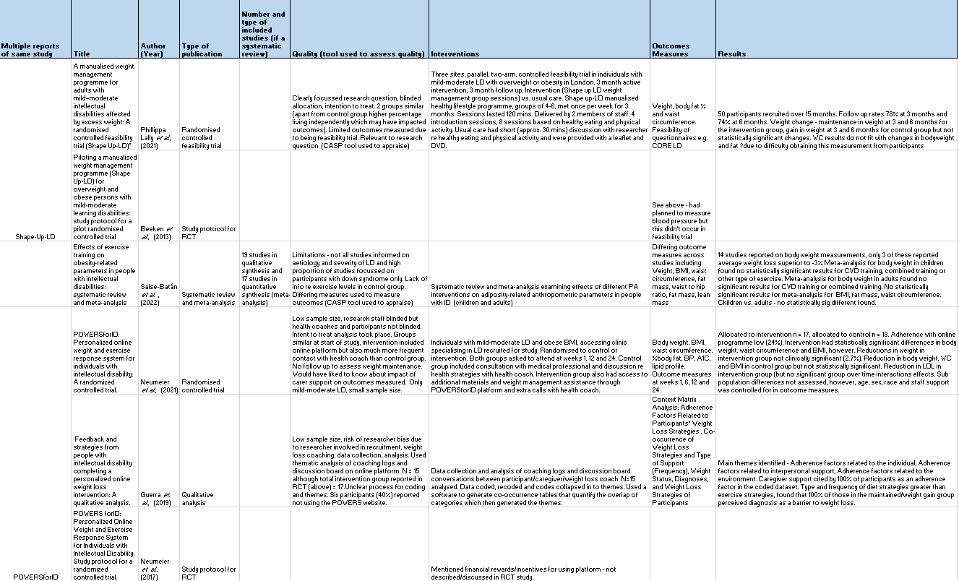
Appendix 1

Appendix 1 cont.

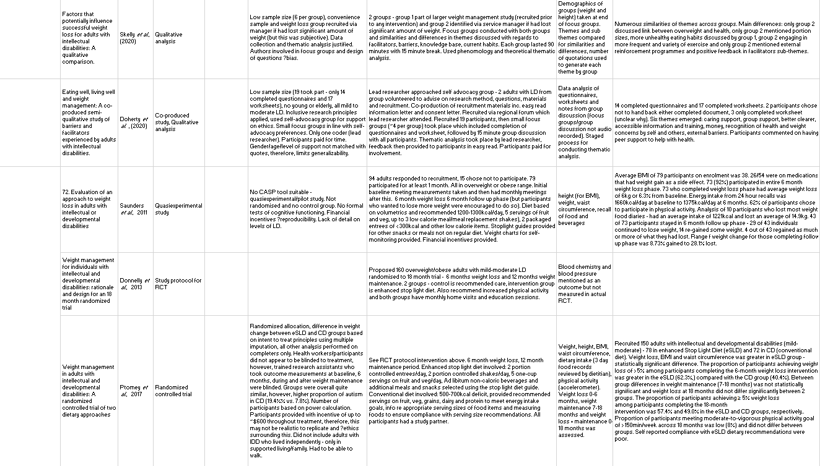
Appendix 1 cont.

Appendix 1 cont.

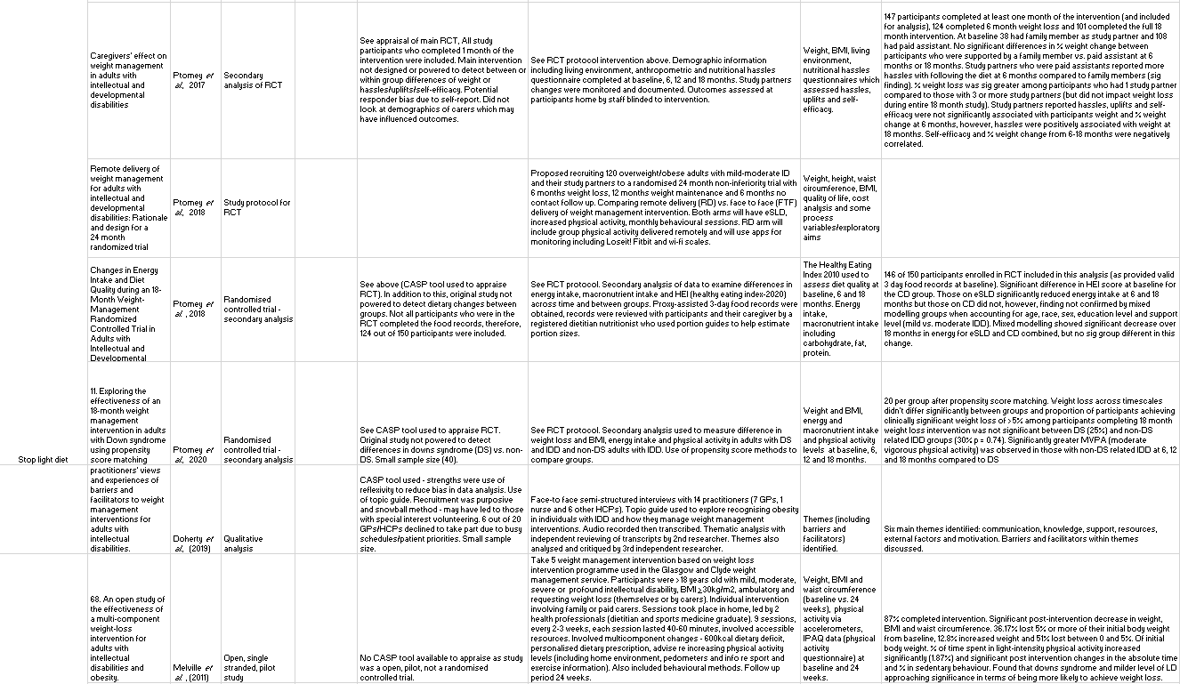
Appendix 1 cont.

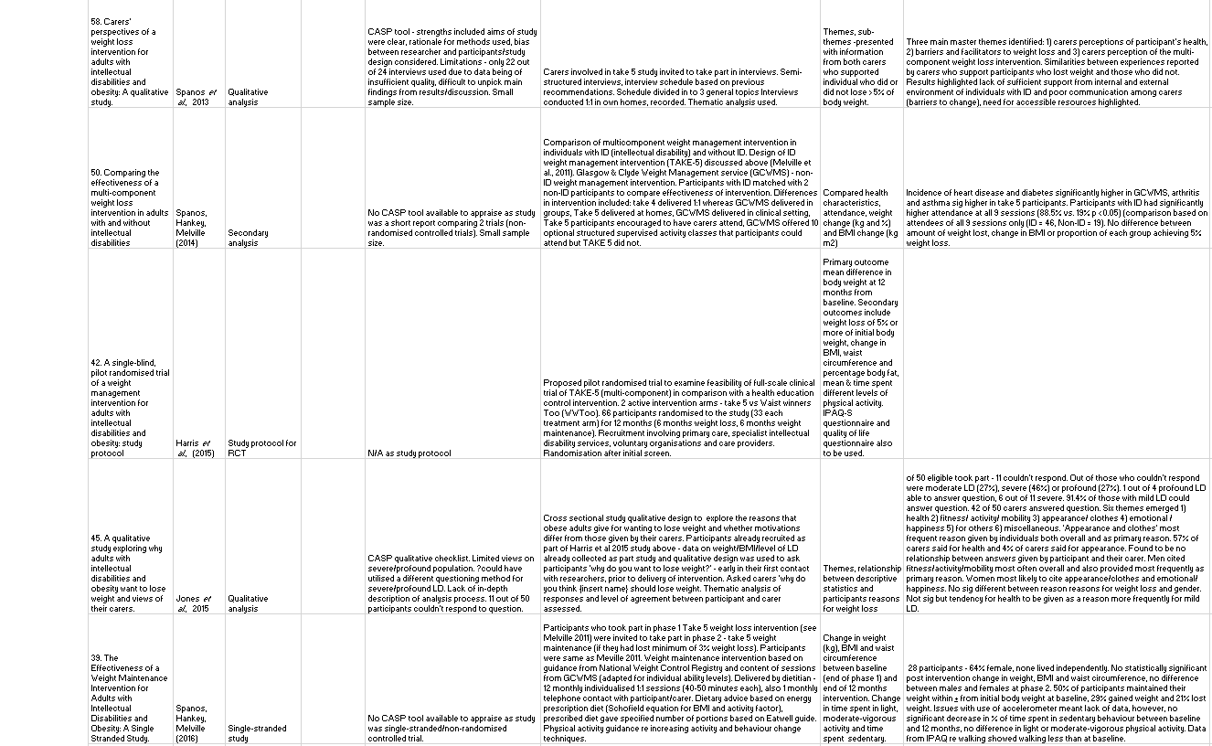
Appendix 1 cont.

Appendix 1 cont.

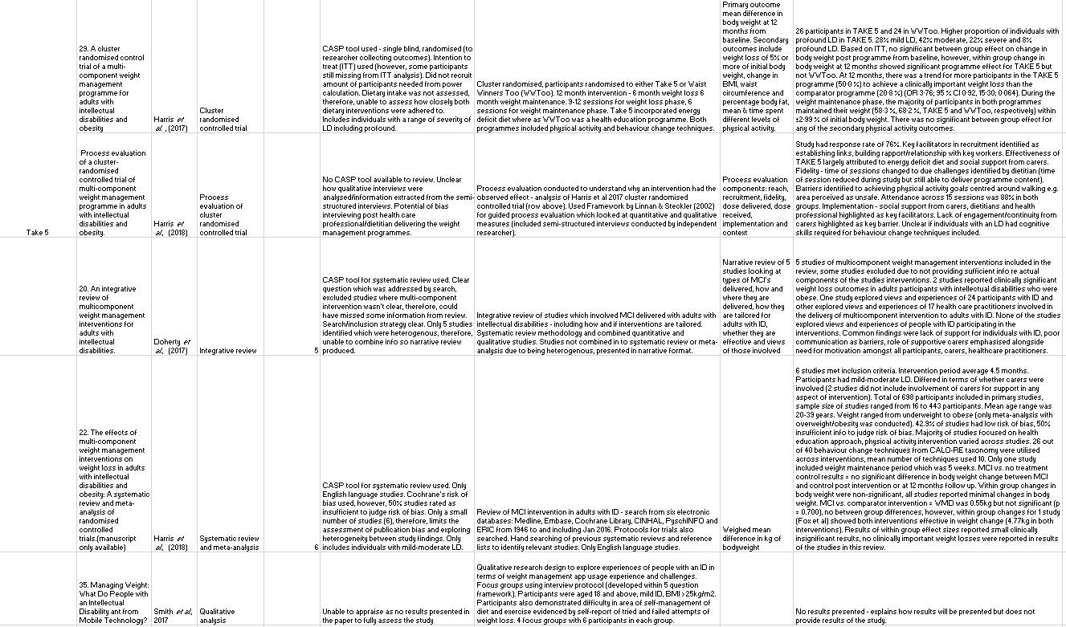
Appendix 1 cont.

Appendix 1 cont.

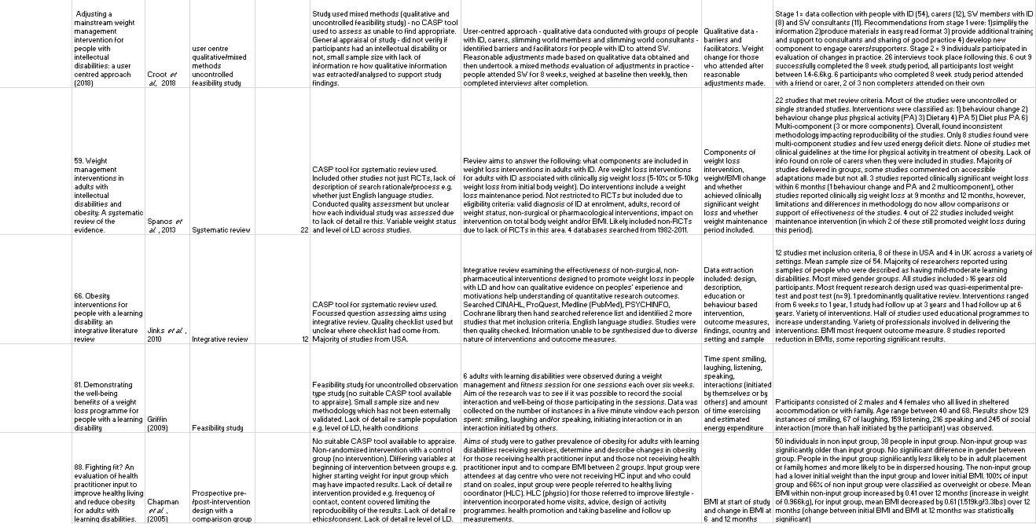
Appendix 1 cont.

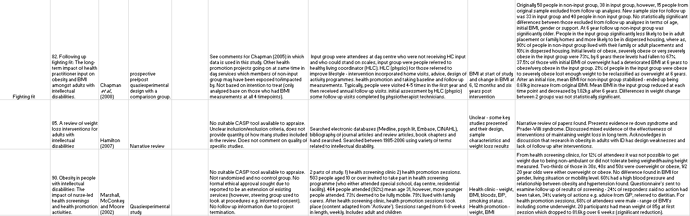
Appendix 1 cont.

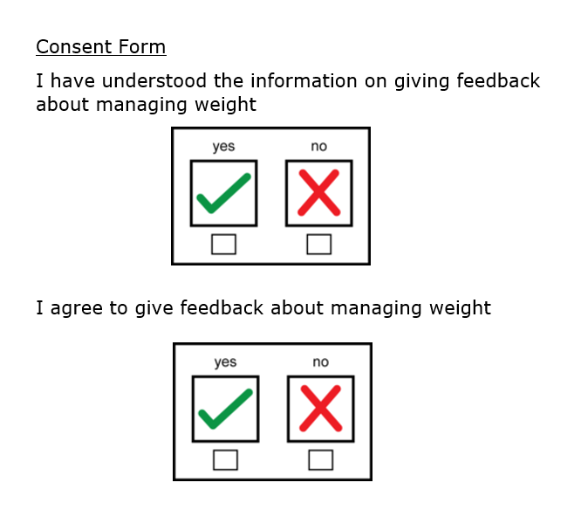
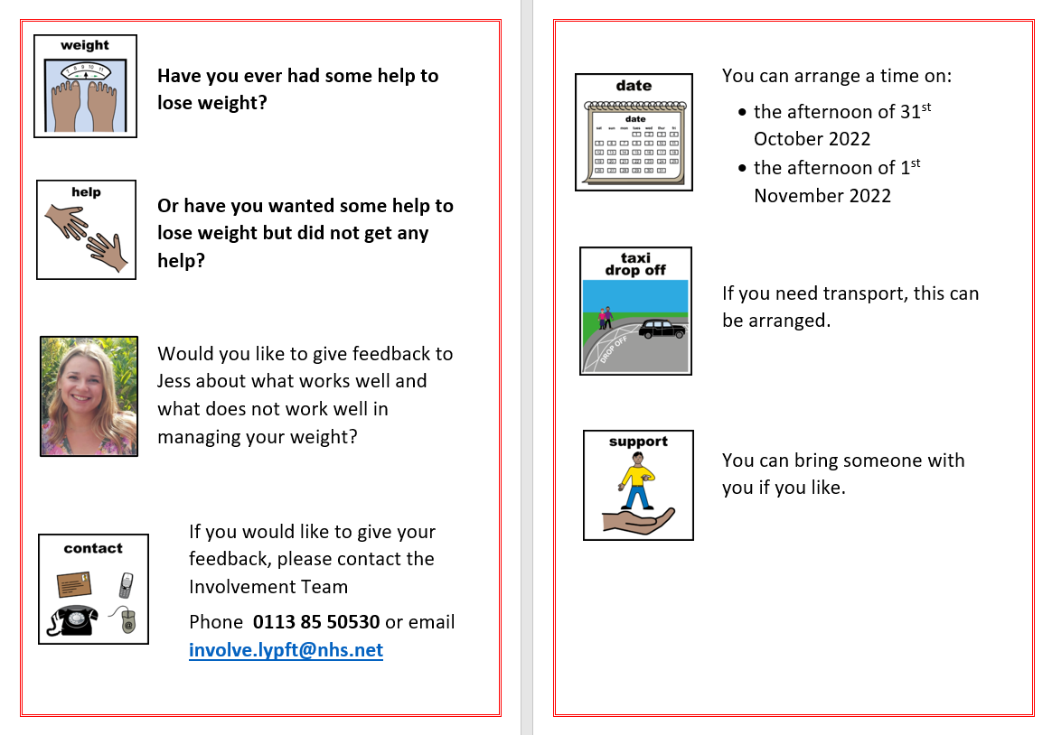
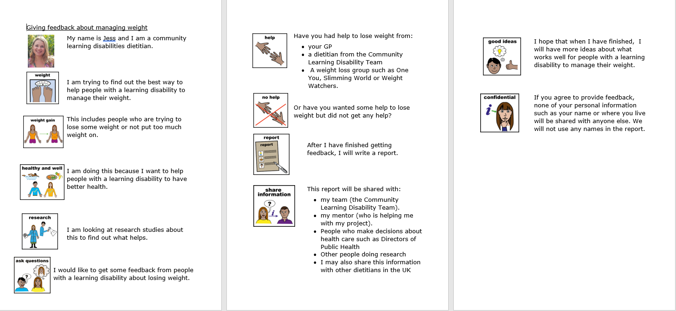
Appendix 2

Appendix 2

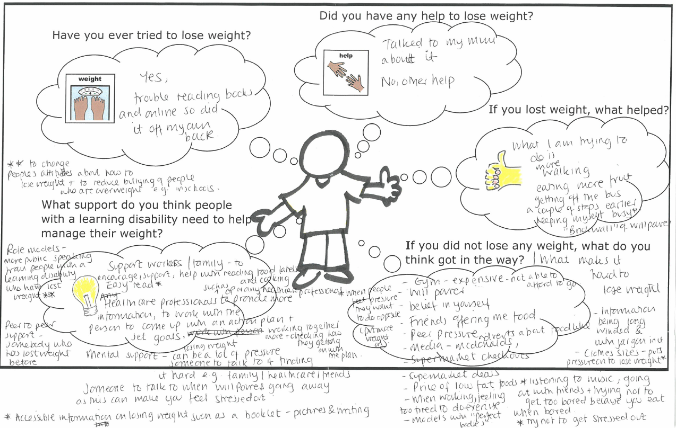
Appendix 3

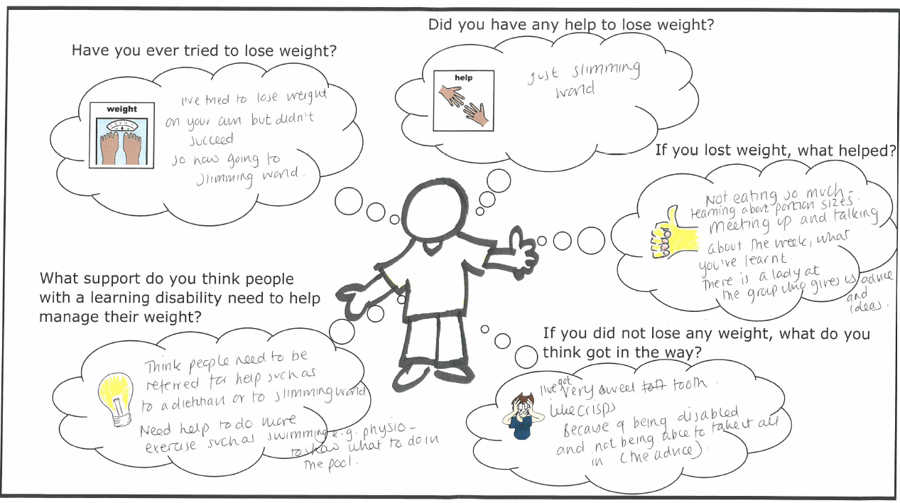
Appendix 4

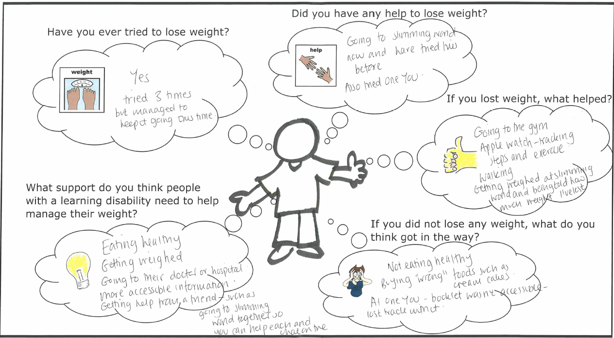
Appendix 5

