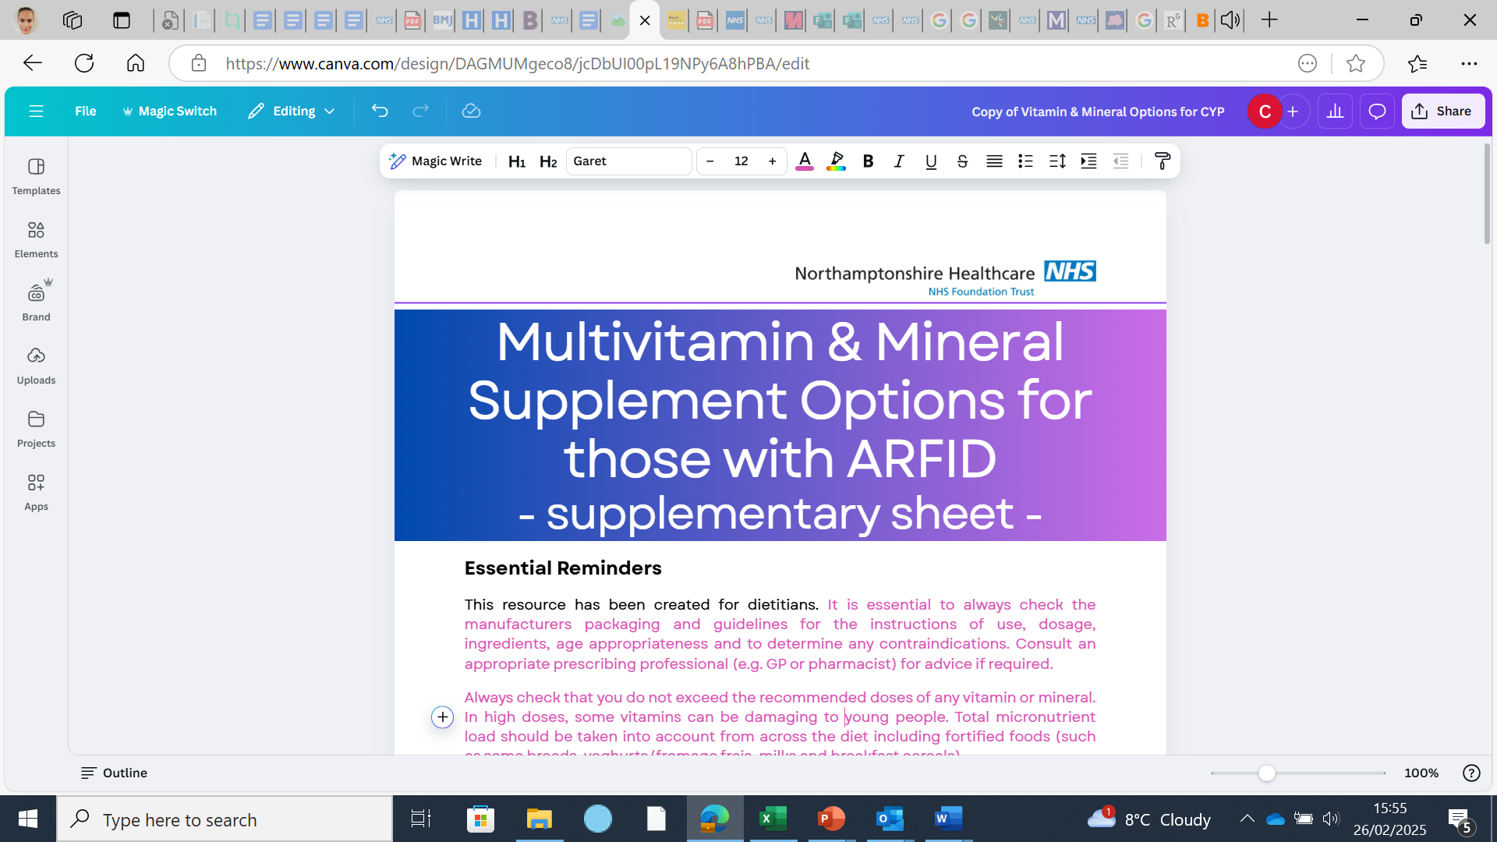

|  |
| --- |
| **About this resource** |

This is a blank supplementary resource intended to support the original resource titled: ‘Multi Vitamin and Mineral Advice and Options for those with ARFID’. It is intended as a tool for dietitians to collate and add further frequently used multi-vitamin and mineral preparations which may be more specific to their care setting.

To use the tool:

* Add the name of the preparation in the first column, under the correctly corresponding sensory preparation
* Add the age range into the second column
* Add an X to indicate whether the supplement is suitable for vegetarians or vegans
* Add an X into each micronutrient box that the supplement contains
* Add a flavour in the end column by using the flavour key (final page)

The table then shows you at quick glance which micronutrient preparation may be suitable for your patients’ needs. The tool is not able to specify the appropriate age range, %DRV, or the necessary dose.

|  |  |  |  |  |  |  |  |  |  |  |  |  |  |  |  |  |  |  |  |  |  |  |  |  |  |  |  |  |  |  |  |  |  |
| --- | --- | --- | --- | --- | --- | --- | --- | --- | --- | --- | --- | --- | --- | --- | --- | --- | --- | --- | --- | --- | --- | --- | --- | --- | --- | --- | --- | --- | --- | --- | --- | --- | --- |
|  |  |  |  |  |  |  |  |  |  |  |  |  |  |  |  |  |  |  |  |  |  |  |  |  |  |  |  |  |  |  |  |  |  |
| **SPRINKLES** | **Age** | **Ve** | **Veg** | **B1** | **B2** | **B3** | **B5** | **B6** | **B7** | **B12** | **D** | **C** | **A** | **E** | **K** | **Na** | **K+** | **Iron** | **Folate** | **Folic** | **Cal** | **Zinc** | **Cu** | **Mg** | **Phos** | **Sel** | **Iodine** | **Chl** | **Mang** | **Moly** | **Chr** | **L.ly** | **Flavour** |
|  |  |  |  |  |  |  |  |  |  |  |  |  |  |  |  |  |  |  |  |  |  |  |  |  |  |  |  |  |  |  |  |  |  |
|  |  |  |  |  |  |  |  |  |  |  |  |  |  |  |  |  |  |  |  |  |  |  |  |  |  |  |  |  |  |  |  |  |  |
|  |  |  |  |  |  |  |  |  |  |  |  |  |  |  |  |  |  |  |  |  |  |  |  |  |  |  |  |  |  |  |  |  |  |
|  |  |  |  |  |  |  |  |  |  |  |  |  |  |  |  |  |  |  |  |  |  |  |  |  |  |  |  |  |  |  |  |  |  |
|  |  |  |  |  |  |  |  |  |  |  |  |  |  |  |  |  |  |  |  |  |  |  |  |  |  |  |  |  |  |  |  |  |  |
| **POWDER** | **Age** | **Ve** | **Veg** | **B1** | **B2** | **B3** | **B5** | **B6** | **B7** | **B12** | **D** | **C** | **A** | **E** | **K** | **Na** | **K+** | **Iron** | **Folate** | **Folic** | **Cal** | **Zinc** | **Cu** | **Mg** | **Phos** | **Sel** | **Iodine** | **Chl** | **Mang** | **Moly** | **Chr** | **L.ly** | **Flav** |
|  |  |  |  |  |  |  |  |  |  |  |  |  |  |  |  |  |  |  |  |  |  |  |  |  |  |  |  |  |  |  |  |  |  |
|  |  |  |  |  |  |  |  |  |  |  |  |  |  |  |  |  |  |  |  |  |  |  |  |  |  |  |  |  |  |  |  |  |  |
|  |  |  |  |  |  |  |  |  |  |  |  |  |  |  |  |  |  |  |  |  |  |  |  |  |  |  |  |  |  |  |  |  |  |
|  |  |  |  |  |  |  |  |  |  |  |  |  |  |  |  |  |  |  |  |  |  |  |  |  |  |  |  |  |  |  |  |  |  |
|  |  |  |  |  |  |  |  |  |  |  |  |  |  |  |  |  |  |  |  |  |  |  |  |  |  |  |  |  |  |  |  |  |  |
| **DROPS** | **Age** | **Ve** | **Veg** | **B1** | **B2** | **B3** | **B5** | **B6** | **B7** | **B12** | **D** | **C** | **A** | **E** | **K** | **Na** | **K+** | **Iron** | **Folate** | **Folic** | **Cal** | **Zinc** | **Cu** | **Mg** | **Phos** | **Sel** | **Iodine** | **Chl** | **Mang** | **Moly** | **Chr** | **L.ly** | **Flav** |
|  |  |  |  |  |  |  |  |  |  |  |  |  |  |  |  |  |  |  |  |  |  |  |  |  |  |  |  |  |  |  |  |  |  |
|  |  |  |  |  |  |  |  |  |  |  |  |  |  |  |  |  |  |  |  |  |  |  |  |  |  |  |  |  |  |  |  |  |  |
|  |  |  |  |  |  |  |  |  |  |  |  |  |  |  |  |  |  |  |  |  |  |  |  |  |  |  |  |  |  |  |  |  |  |
|  |
|  |  |  |  |  |  |  |  |  |  |  |  |  |  |  |  |  |  |  |  |  |  |  |  |  |  |  |  |  |  |  |  |  |  |  |
|  |  |  |  |  |  |  |  |  |  |  |  |  |  |  |  |  |  |  |  |  |  |  |  |  |  |  |  |  |  |  |  |  |  |  |
|  |
| **LIQUID / SYRUP** | **Age** | **Ve** | **Veg** | **B1** | **B2** | **B3** | **B5** | **B6** | **B7** | **B12** | **D** | **C** | **A** | **E** | **K** | **Na** | **K+** | **Iron** | **Folate** | **Folic** | **Cal** | **Zinc** | **Cu** | **Mg** | **Phos** | **Sel** | **Iodine** | **Chl** | **Mang** | **Moly** | **Chr** | **L.ly** | **Flav.** |  |
|  |  |  |  |  |  |  |  |  |  |  |  |  |  |  |  |  |  |  |  |  |  |  |  |  |  |  |  |  |  |  |  |  |  |  |
|  |  |  |  |  |  |  |  |  |  |  |  |  |  |  |  |  |  |  |  |  |  |  |  |  |  |  |  |  |  |  |  |  |  |  |
|  |  |  |  |  |  |  |  |  |  |  |  |  |  |  |  |  |  |  |  |  |  |  |  |  |  |  |  |  |  |  |  |  |  |  |
|  |  |  |  |  |  |  |  |  |  |  |  |  |  |  |  |  |  |  |  |  |  |  |  |  |  |  |  |  |  |  |  |  |  |  |
|  |  |  |  |  |  |  |  |  |  |  |  |  |  |  |  |  |  |  |  |  |  |  |  |  |  |  |  |  |  |  |  |  |  |  |
| **GUMMY** | **Age** | **Ve** | **Veg** | **B1** | **B2** | **B3** | **B5** | **B6** | **B7** | **B12** | **D** | **C** | **A** | **E** | **K** | **Na** | **K+** | **Iron** | **Folate** | **Folic** | **Cal** | **Zinc** | **Cu** | **Mg** | **Phos** | **Sel** | **Iodine** | **Chl** | **Mang** | **Moly** | **Chr** | **L.ly** | **Flav** |  |
|  |  |  |  |  |  |  |  |  |  |  |  |  |  |  |  |  |  |  |  |  |  |  |  |  |  |  |  |  |  |  |  |  |  |  |
|  |  |  |  |  |  |  |  |  |  |  |  |  |  |  |  |  |  |  |  |  |  |  |  |  |  |  |  |  |  |  |  |  |  |  |
|  |  |  |  |  |  |  |  |  |  |  |  |  |  |  |  |  |  |  |  |  |  |  |  |  |  |  |  |  |  |  |  |  |  |  |
|  |  |  |  |  |  |  |  |  |  |  |  |  |  |  |  |  |  |  |  |  |  |  |  |  |  |  |  |  |  |  |  |  |  |  |
|  |  |  |  |  |  |  |  |  |  |  |  |  |  |  |  |  |  |  |  |  |  |  |  |  |  |  |  |  |  |  |  |  |  |  |
| **CHEWY** | **Age** | **Ve** | **Veg** | **B1** | **B2** | **B3** | **B5** | **B6** | **B7** | **B12** | **D** | **C** | **A** | **E** | **K** | **Na** | **K+** | **Iron** | **Folate** | **Folic** | **Cal** | **Zinc** | **Cu** | **Mg** | **Phos** | **Sel** | **Iodine** | **Chl** | **Mang** | **Moly** | **Chr** | **L.ly** | **Flav** |  |
|  |  |  |  |  |  |  |  |  |  |  |  |  |  |  |  |  |  |  |  |  |  |  |  |  |  |  |  |  |  |  |  |  |  |  |
|  |  |  |  |  |  |  |  |  |  |  |  |  |  |  |  |  |  |  |  |  |  |  |  |  |  |  |  |  |  |  |  |  |  |  |
|  |  |  |  |  |  |  |  |  |  |  |  |  |  |  |  |  |  |  |  |  |  |  |  |  |  |  |  |  |  |  |  |  |  |  |
|  |  |  |  |  |  |  |  |  |  |  |  |  |  |  |  |  |  |  |  |  |  |  |  |  |  |  |  |  |  |  |  |  |  |  |
|  |  |  |  |  |  |  |  |  |  |  |  |  |  |  |  |  |  |  |  |  |  |  |  |  |  |  |  |  |  |  |  |  |  |  |
| **TABLET** | **Age** | **Ve** | **Veg** | **B1** | **B2** | **B3** | **B5** | **B6** | **B7** | **B12** | **D** | **C** | **A** | **E** | **K** | **Na** | **K+** | **Iron** | **Folate** | **Folic** | **Cal** | **Zinc** | **Cu** | **Mg** | **Phos** | **Sel** | **Iodine** | **Chl** | **Mang** | **Moly** | **Chr** | **L.ly** | **Flav** |  |
|  |  |  |  |  |  |  |  |  |  |  |  |  |  |  |  |  |  |  |  |  |  |  |  |  |  |  |  |  |  |  |  |  |  |  |
|  |  |  |  |  |  |  |  |  |  |  |  |  |  |  |  |  |  |  |  |  |  |  |  |  |  |  |  |  |  |  |  |  |  |  |
|  |  |  |  |  |  |  |  |  |  |  |  |  |  |  |  |  |  |  |  |  |  |  |  |  |  |  |  |  |  |  |  |  |  |  |
|  |  |  |  |  |  |  |  |  |  |  |  |  |  |  |  |  |  |  |  |  |  |  |  |  |  |  |  |  |  |  |  |  |  |  |
|  |  |  |  |  |  |  |  |  |  |  |  |  |  |  |  |  |  |  |  |  |  |  |  |  |  |  |  |  |  |  |  |  |  |  |
|  |
| **EFFERVESCENT** | **Age** | **Ve** | **Veg** | **B1** | **B2** | **B3** | **B5** | **B6** | **B7** | **B12** | **D** | **C** | **A** | **E** | **K** | **Na** | **K+** | **Iron** | **Folate** | **Folic** | **Cal** | **Zinc** | **Cu** | **Mg** | **Phos** | **Sel** | **Iodine** | **Chl** | **Mang** | **Moly** | **Chr** | **L.ly** | **Flav** |  |
|  |  |  |  |  |  |  |  |  |  |  |  |  |  |  |  |  |  |  |  |  |  |  |  |  |  |  |  |  |  |  |  |  |  |  |
|  |  |  |  |  |  |  |  |  |  |  |  |  |  |  |  |  |  |  |  |  |  |  |  |  |  |  |  |  |  |  |  |  |  |  |
|  |  |  |  |  |  |  |  |  |  |  |  |  |  |  |  |  |  |  |  |  |  |  |  |  |  |  |  |  |  |  |  |  |  |  |
|  |  |  |  |  |  |  |  |  |  |  |  |  |  |  |  |  |  |  |  |  |  |  |  |  |  |  |  |  |  |  |  |  |  |  |
|  |  |  |  |  |  |  |  |  |  |  |  |  |  |  |  |  |  |  |  |  |  |  |  |  |  |  |  |  |  |  |  |  |  |  |
| **SPRAY** | **Age** | **Ve** | **Veg** | **B1** | **B2** | **B3** | **B5** | **B6** | **B7** | **B12** | **D** | **C** | **A** | **E** | **K** | **Na** | **K+** | **Iron** | **Folate** | **Folic** | **Cal** | **Zinc** | **Cu** | **Mg** | **Phos** | **Sel** | **Iodine** | **Chl** | **Mang** | **Moly** | **Chr** | **L.ly** | **Flav** |  |
|  |  |  |  |  |  |  |  |  |  |  |  |  |  |  |  |  |  |  |  |  |  |  |  |  |  |  |  |  |  |  |  |  |  |  |
|  |  |  |  |  |  |  |  |  |  |  |  |  |  |  |  |  |  |  |  |  |  |  |  |  |  |  |  |  |  |  |  |  |  |  |
|  |
|  |  |  |  |  |  |  |  |  |  |  |  |  |  |  |  |  |  |  |  |  |  |  |  |  |  |  |  |  |  |  |  |  |  |  |
|  |  |  |  |  |  |  |  |  |  |  |  |  |  |  |  |  |  |  |  |  |  |  |  |  |  |  |  |  |  |  |  |  |  |  |
|  |  |  |  |  |  |  |  |  |  |  |  |  |  |  |  |  |  |  |  |  |  |  |  |  |  |  |  |  |  |  |  |  |  |  |

|  |  |
| --- | --- |
| Table Key | |
| Age | A - Adult 18 years and above  Number- Age in years e.g. 12y+ represents 12 years and over  Months- Age in months e.g. 3m+ represents 3months and over |
| Ve | Vegan |
| Veg | Vegetarian |
| B1 | Vitamin B1 (Thiamine) |
| B2 | Vitamin B2 (Riboflavin) |
| B3 | Vitamin B3 (Niacin) |
| B5 | Vitamin B5 (Pantothenic Acid) |
| B6 | Vitamin B6 (Pyridoxine) |
| B7 | Vitamin B7 (Biotin) |
| B12 | Vitamin B12 (Cobalamin) |
| D | Vitamin D |
| C | Vitamin C |
| A | Vitamin A |
| E | Vitamin E |
| K | Vitamin K |
| Na | Sodium |
| K+ | Potassium |
| Iron | Iron |
| Folate | Folate |
| Folic | Folic Acid |
| Cal | Calcium |
| Zinc | Zinc |
| Cu | Copper |
| Mg | Magnesium |
| Phos | Phosphorus |
| Sel | Selenium |
| Iodine | Iodine |
| Chl | Chlorine |
| Mang | Manganese |
| Moly | Molybdenum |
| Chr | Chromium |
| L.ly | L. Lysine |
| Flavours Key | |
| AB | Apple and Blackcurrant |
| Bl | Blueberry |
| BP | Blackcurrant and Plum |
| Br | Berry |
| C | Cherry |
| CM | Chocolate and Marshmallow |
| F | Fruit |
| G | Grape |
| O | Orange |
| P | Peppermint |
| PA | Pineapple |
| PO | Pomegranate |
| PR | Pomegranate and Raspberry |
| R | Raspberry |
| SM | Strawberry Milkshake |
| Tr | Tropical |
| U | Unflavoured |