Low-fat cooking methods are best: grill, griddle, boil, dry-roast (without added fat) poach or steam rather than fry. | 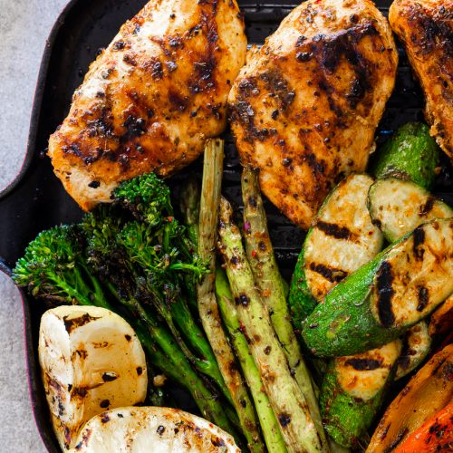
Base your meals and snacks on carbohydrates such as pasta, rice, potatoes and whole grains. | 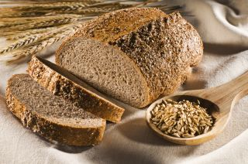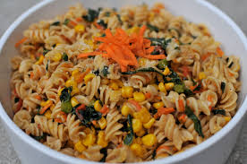
Have several small meals during the day, without long gaps in between. | 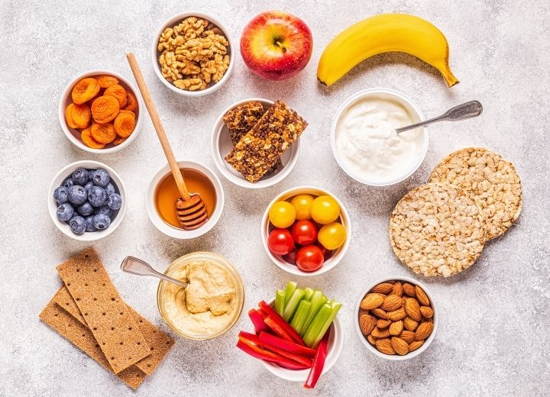
Use unsaturated fat spreads, choose from olive or vegetable oil rather than butter. This helps to lower blood cholesterol. | 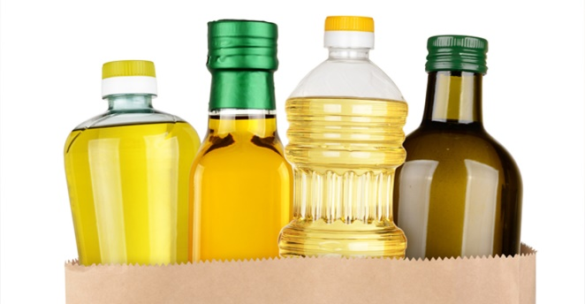
Trim all the fat from your meat. | 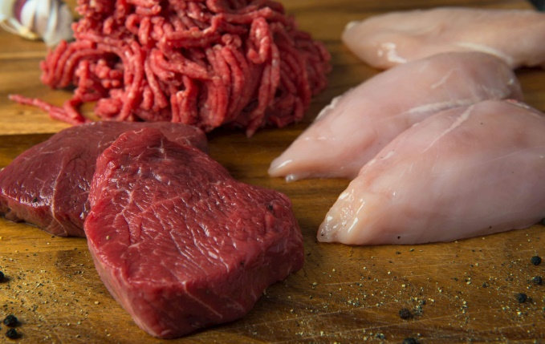
HEALTHY EATING TOP TIPS

Use peas, beans, lentils and chickpeas to extend meat dishes. For example mixing cooked lentils into a Bolognese sauce will make it go further, and will keep you fuller for longer. | 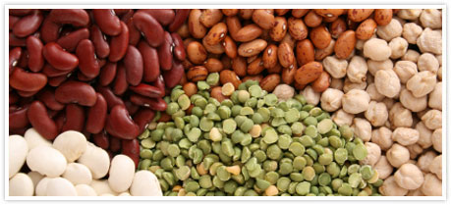
Think of vegetables as the main part of the meal, rather than an accompaniment. | 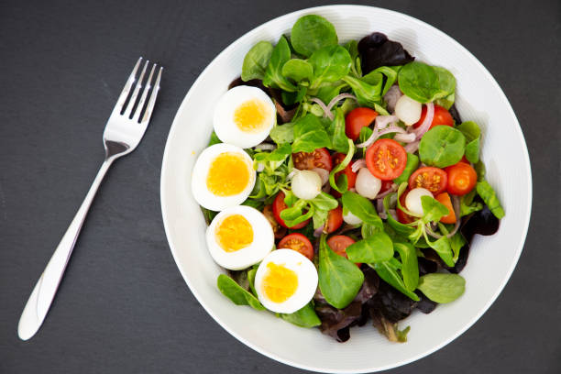  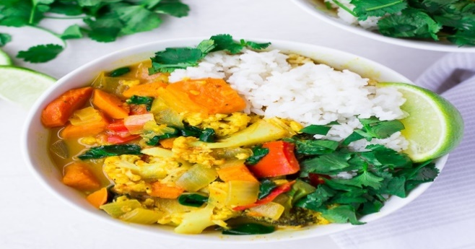
Base desserts on fresh fruit, fruit canned in natural juice, low-fat natural yoghurt or fromage frais. | 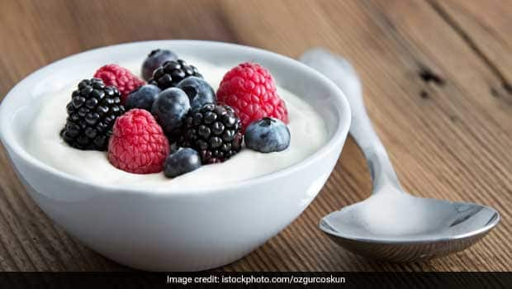
Enjoy crunchy raw vegetables as snacks. You could keep ‘hunger boxes’ in the fridge, filled with a variety of chopped fresh fruit and vegetables. | 