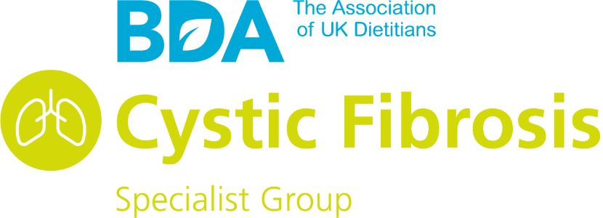
CF Dietitians Group Educational Award
Dear Members,
You are invited to apply for our group Educational Award. This award is to support your attendance at an educational event of your choice i.e. ECFS, NACF conference, or other educational meeting. Ideally, you will have submitted and had accepted an abstract, e-poster or case presentation to the event you would like to attend. We would particularly welcome applications from new members or those new to the specialist area of CF.
All submissions will be reviewed by the committee of the CF Specialist Group and applicants will be asked to present their work or case study at a future meeting or event.
If you have submitted an abstract or case presentation to another conference or educational event, we would love to hear about it!

CONTINUING FOR 2024/25!! We are happy to consider any applications for funds which would allow members to attend training and development opportunities over the coming year. We have two deadlines so that there is more opportunity to seek support to attend an educational event.

Please submit all applications to the committee on cysticfibrosisgroup@bda.uk.com
by March 1st (for ECFC) 2025.

Good Luck and we look forward to your application!

CFDG Educational Award Entry Application Form
Name
Current Role
Hospital
Work Address
Contact Phone Number
Email Address
How long have you been working in CF?
What would you use the educational award for?
Title of Presentation (Titles should be written in sentence case, i.e.: This abstract title is written in sentence case)

Abstract/ Case Presentation (The abstract body may be no longer than 500 words, tables are permitted, however please be aware that each row of the table will be counted as ten words against your 500 words total. The maximum number of tables allowed per abstract is two. The abstract body is to be single line spaced. Standard abbreviations are acceptable. Any special abbreviations should be given in parenthesis after the first appearance of the full word or phrase for which it stands.)

