- Eat three meals a day
- Aim for smaller carbohydrate portions at meal times (for rice, pasta, noodles and chips eat no more than the size of your hand in a clenched fist shape)
- Ensure have some protein and more fibre at meal times (these foods help you feel full)
- Avoid eating in-between meals (eating in-between meals stops fat burning)
- Drink plenty of water in-between meals (helps fill you up and helps stop hunger)
- Include some dairy foods each day (for calcium)
- Eat some good fats (helps you feel full)
Protein foods - eat at each meal
- All meats (beef, lamb, pork, venison)
- All poultry (chicken, turkey, duck)
- All fish (including tinned fish)
- Sausages, bacon and ham
- Cheese (small portion)
- Eggs
- Handful nuts or seeds
- Pulses (lentils, chickpeas etc.)
Dairy foods – include some dairy foods each day
- Yoghurt (avoid sugary yoghurts)
- Cheese (small portion)
- 200 ml of milk per day
Carbohydrate foods - eat smaller portions
- Bread, wraps, rolls, croissants, bagels etc.
- Pasta, rice, chips, crisps, noodles
- Cakes, pastries, biscuits, crackers, sweets, ice cream
- Breakfast cereals
- High carbohydrate fruit – grapes bananas, melons, mango, all fruit juice, sugary drinks
Fibre foods – eat larger portions at meal times
- All vegetables
- All salad
- Lower carb fruit – apples, oranges, satsumas, kiwi fruit, plums, strawberries, raspberries, blueberries, blackberries (including frozen berries), melon.
Good activities
- Walking and running
- Cycling
- Dancing
- All sports
- Housework and cleaning
- Gym

Good fats to include
- Olive oil (avoid all other vegetable oils)
- Avocado
- Olives
- No added sugar peanut butter
- Oily fish (mackerel, sardines, salmon, herring)

Suggested Breakfasts/Brunch: (note to help increase protein on breakfast cereals – add some lower carb/high protein yoghurts or some pumpkin seeds or sunflower seeds)
- Porridge sachet made with milk
- 2 weetabix with milk
- Cooked breakfast – eggs, sausage or bacon, mushrooms, tomatoes and 1 slice of toast
- Scrambled eggs on 1 slice of toast
- Smoked mackerel or smoked salmon on 1 slice of toast
- Banana pancake (see recipe) served with lower carb/high protein yoghurt

Suggested Lunches: ( have apple, orange, kiwi or berries after lunch)
- Large Tuna salad with mayonnaise
- Large cheese salad or ham salad with mayonnaise
- Cheese salad or beef/ham salad sandwiches (use double portions of cheese or beef to increase the protein of lunch) with 1 apple or 2 satsumas or 1 orange
- Jacket potato with cheese or tuna and salad or with chilli con carne
- Cheese pasta pot

Suggested evening meals -family meal at home:
- Shepherds pie or cottage pie with vegetables or salad
- Steak and small portion of chips or sweet potato chips with vegetables or salad
- Chicken or turkey with potatoes with vegetables or salad
- Lasagne with vegetables or salad
- Fish with potatoes or rice and vegetables or salad
- Big bowl of butternut squash and vegetable soup with cheese topping and 1 small bread roll
- Take out meal (limit to once per week)
- Spaghetti bolognaise served with vegetables and salad
- Meatballs or meat patties with mashed potatoes and vegetables or salad
- Jacket potato with cheese or tuna and salad or with chilli con carne
- Sausages and mash served with vegetables or salad
- Family meal (cultural foods/meal)
- Chicken pie with vegetables

Suggested desserts (for after evening meal:
- 25 g of cheddar cheese (matchbox size)
- 1 lower carb/high protein yoghurt pot (see links on page 4)
- Berries and Greek yoghurt (can have frozen berries)
- Low sugar apple crumble (see recipe)
- Apple or 2 satsumas or 1 orange or 2 kiwi fruit
- 20 grams of salted peanuts
- Fruit salad with yoghurt or double cream
- Dark chocolate ( 2 squares)
- Home made ice cream (use dates or honey to replace sugar)
- Fresh coconut
- 200 ml of semi skimmed milk

Suggested drinks:
- Drink mainly water
- Occasional no added sugar squash or occasional sugar free drink
- Occasional tea or coffee with milk (no sugar)
- Occasional low calorie hot chocolate

Avoid in-between meal snacks – however choose one of these if need to have one in-between meal snack per day:
- 1 boiled egg
- 20 grams of salted peanuts or some peanut butter with 1 oatcake
- 1 slice of meat or chicken or ham with salad
- Packet of biltong (choose lower carb brands)
- 1 -2 packets of seaweed thins https://www.tesco.com/groceries/en-GB/products/279834507
- Small tuna or cheese salad with real mayonnaise
- Packet of Hippeas or salted popcorn, or Wotsits
- 1 slice of toast with no added sugar peanut butter or low fat cheese spread
- Olives
- Avocado on 1/2 slice of toast
- 7 walnuts or 7 cashew nuts or 7 almonds
- 2 squares of dark chocolate
- 1 low calorie hot chocolate
- 2 satsumas or 1 orange or 1 apple or melon pieces
- Portion of berries served with double cream or Greek yoghurt
- Fresh coconut
- Coconut chips
- Houmous with carrot or cucumber sticks
- Cut up sticks of pepper, carrot, cucumber, celery with cream cheese or cheddar cheese
- Meat pattie with lettuce wrap and real mayonnaise (see recipe for meat pattie)

Recipe for meat patties:
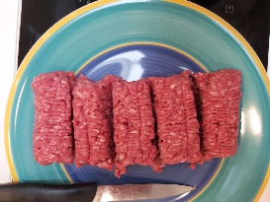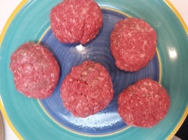
- 500 gram pack of 10% fat mince beef.
  - Divide the pack of mince beef into 5 portions and shape with your hands to make a ‘pattie’ shape or a burger shape.
  - Add a tiny bit of butter to melt in the bottom of the pan and place the patties in the pan and cook on both sides until cooked through
  - Keep in fridge for up to 4 days or freeze for 2 months
  - Serve with salt and pepper or with some melted cheese wrapped in a lettuce leaf with no-added sugar tomato ketchup or mayonnaise and some sliced tomatoes.

Low carb banana pancake:
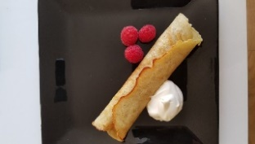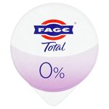

- 1 small banana (or ½ medium size banana)
- 1 medium egg
- 5 grams of butter (1 heaped teaspoon)
- 2 teaspoons SR flour

  - Mash the banana really well so that it forms a puree using the back of a fork on a dinner plate. Beat the egg well and add the well mashed banana and the flour. Melt the butter in a non-stick fry pan and let the butter cool a little. Using a silicone spatula scrape all of the butter into the egg and banana mixture. Mix well. Pour the whole pancake mixture in the non-stick pan on medium heat (or can make 2 smaller pancakes). Push the edges of the pancake into the middle just a little so that the pancake does not spread too much and will be easier to flip. Flip the pancake when cooked on one side. When cooked can eat on its own or add some Greek yoghurt and berries (or lemon juice).

Apple crumble (makes 6 – 8 portions)
- 5 medium size English eating apples
- 230 ml water
- 90 grams of butter
- 120 grams of plain flour
- 90 grams of oats
- 30 grams of sugar (Demerara is best) or 30 grams of honey
- 1 teaspoon of ground dry cinnamon or 1 teaspoon of ground dry ginger (optional)
Method (only need one saucepan)
- Wash the apples. Weigh the apples and record weight in worksheet (weigh whole).
- Cut up the apples into small pieces (take out the core, but leave the skin on – skin is good source of fibre, vitamins and minerals).
- Put the cut up apples with 230 ml of water in a saucepan. Boil and then simmer for 15 minutes – leave the saucepan lid on.
- Once the apples are cooked (soft), pour them into a baking dish (approx size baking dish 9 inches by 7 inches).
- Weigh other ingredients.
- Don’t wash the saucepan. Put the butter in the saucepan and put on gentle heat so that the butter melts but does not burn.
- One the butter has melted, turn the heat off and add the sugar, flour and oats and cinnamon or ginger and stir with a wooden spoon until the mixture is like breadcrumbs.
- Pour the breadcrumb mixture on top of the apples (in baking dish). Put tin foil on top of baking dish.
- Place in oven at 160 C for 20 minutes.
- Lower carb/higher protein yoghurts
https://www.tesco.com/groceries/en-GB/products/299650550
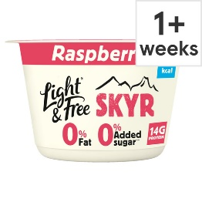
https://www.tesco.com/groceries/en-GB/products/305738909
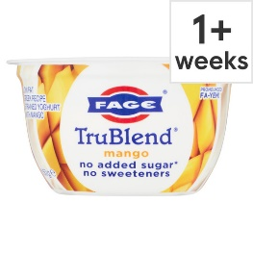
https://www.tesco.com/groceries/en-GB/products/268279288
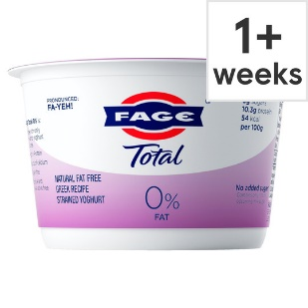

https://www.sainsburys.co.uk/gol-ui/product/dairy-eggs-new/yeo-valley-super-thick-5-natural-450g
https://www.yeovalley.co.uk/things-we-make/yogurt/super-thick-kerned-0-fat-natural/

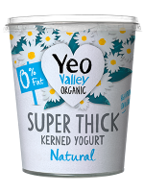

Lower carb breads:
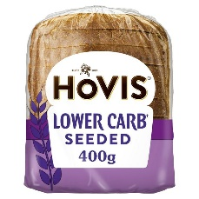 https://www.sainsburys.co.uk/gol-ui/product/grain-seeded-bread/hovis-lower-carb-deliciously-seeded-400g
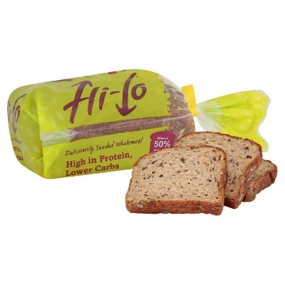 https://www.sainsburys.co.uk/gol-ui/product/wholemeal-brown-bread/hi-lo-loaf
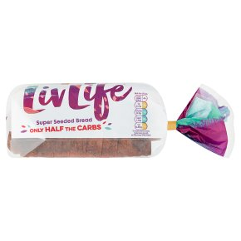
https://www.waitrose.com/ecom/products/livlife-seriously-seeded-sliced-bread/869667-288713-288714

Lower carb oatcakes:
https://www.tesco.com/groceries/en-GB/products/259469618
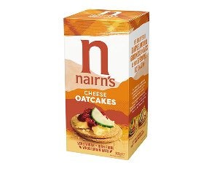

Low carb wrap and pizza base (very high fibre so helps prevent hunger):
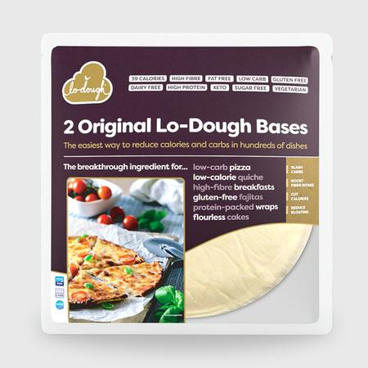
https://lodough.co/
Some lower carb websites with recipe ideas:
https://www.bbcgoodfood.com/recipes/collection/low-carb-snacks-recipes
https://www.bbcgoodfood.com/recipes/collection/low-carbohydrate-recipes
https://www.bbcgoodfood.com/howto/guide/recipes-teenagers
https://www.olivemagazine.com/guides/best-ever/best-ever-low-carb-recipes/
https://www.caldesi.com/category/recipes/
https://www.lowcarbtogether.com/
https://thelowcarbkitchen.co.uk/

Beginners’ exercises – You Tube

No equipment needed:
https://www.youtube.com/watch?v=48HMCy5F6Vg

Using dumbells:
https://www.youtube.com/watch?v=L3eImBAXT7I

or
https://www.youtube.com/watch?v=r9M6CcJFMDU

Fun UK workout:
https://www.youtube.com/watch?v=gC_L9qAHVJ8

A little harder workout (8 minutes long):
https://www.youtube.com/watch?v=ixjdNUtWN-Y

