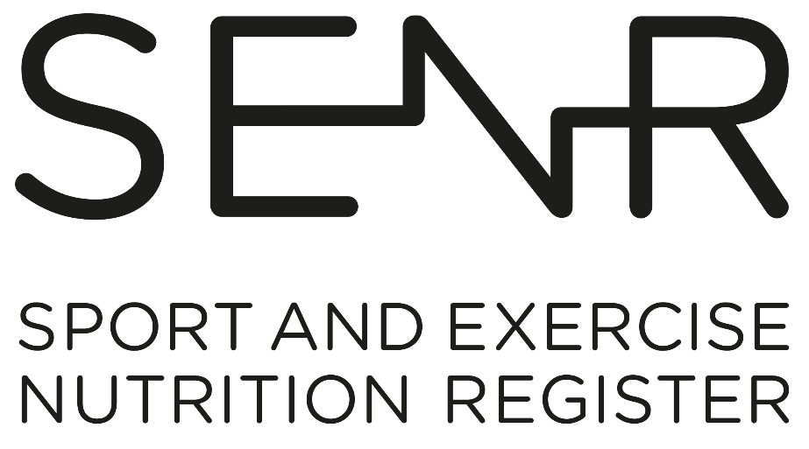

Competency Framework for the Sport and Exercise Nutrition Register (SENR)
Graduate Registration - Non-SENR accredited courses
October 2024

Introduction

Sport and exercise nutritionists enter the profession as a Graduate Registrant and develop competency through practice during their early post-registration years. They are encouraged to engage in continual professional development to advance their practice and deliver better outcomes for service users as they work towards achieving full Practitioner Registration status.

This document describes in detail the collection of competencies applicants will be expected to demonstrate in order to achieve Graduate Registration.

All applicants (both for Graduate and Practitioner status) must meet the competency requirements in Section A, thus demonstrating robust and sound academic subject knowledge. This will be achieved through a combination of undergraduate and postgraduate study as outlined on the BDA website. Meeting the requirements set out in Section A will ensure an applicant’s eligibility to join the SENR Graduate Register.

Competencies required for SENR Graduate registration
All competencies in Section A are deemed to be Essential and must be met by all applicants.

No. | Scientific Knowledge
A1 | Foundation in Biosciences
A1.1 | Know and understand the human body and its functions, especially digestion, absorption, excretion, respiration, fluid and electrolyte balance, the cardio-vascular system, neuro-endocrine system, musculoskeletal system, immunity, and thermoregulation.
A1.2 | Know and understand mechanisms for the integration of metabolism at molecular, cellular, and whole-body levels.
A2 | Science of Sport and Exercise Nutrition
A2.1 | Basic Nutrition
A2.1.1 | Know, understand, and have the ability to critically evaluate methods of measurement and evaluation including anthropometric, dietary, biochemical, physiological and functional methods of assessment.
A2.1.2 | Know, understand, and have the ability to critically evaluate the theory and methods of investigating the dietary and nutrient patterns of the general population and subgroups of the population. This will include analysis of qualitative and quantitative dietary and nutritional data, utilising database systems as appropriate.
A2.1.3 | Know, understand, and critically evaluate nutrition science and its role in promoting human health including the:  - role of macro and micronutrients and other metabolically active components of food (e.g., fibre);  - metabolic effects of anti-nutrients (e.g., tannins), food additives, pharmacologically active agents (drugs);  - nutrient-nutrient interactions;  - potential of ‘nutraceuticals’ and functional foods;  - the nutritional composition of foods.
A2.1.4 | Know, understand, and have the ability to critically evaluate the scientific basis for the measurement and estimation of nutritional requirements, limitations and usefulness of dietary reference values and recommended dietary allowances for the general population and safe upper levels of individual nutrients including in the context of the special needs of vulnerable groups.
A2.1.5 | Know and understand the aetiology of nutritional or nutrition-related problems that are relevant to sport and exercise performance.
A2.1.6 | Know and understand how to take ethnicity or culture into account in formulating practical advice in terms of foods, meals, and menus.
A2.1.7 | Know and understand how to take dietary preferences into account in formulating practical advice in terms of foods, meals and menus (e.g., vegetarian and plant-based eating).
A2.1.8 | Know and understand the principles of food preparation, handling, management, and safety.
A2.2 | Specialist Knowledge in Sport and Exercise Nutrition
A2.2.1 | Know and understand the nature of different sports to ensure an interdisciplinary approach to nutrition support to include:  - principles and components of fitness;  - physiological and biochemical demands of participation in sport and exercise;  - training practices, physical demands and rules of sports;  - lifestyles of clients;  - the nutritional implications of the physiological demands of training for and competing in sport and exercise.
A.2.2.2 | Know, understand, and critically evaluate the theoretical basis for the metabolic effects, efficacy, health, safety, and legal aspects of ergogenic aids of all kinds including pharmacologically active agents, sports foods, sports drinks, and supplements demonstrating an awareness of clean sport principles, current WADA prohibited list and practitioner responsibilities when operating in this area of practice.
A2.2.3 | Appreciate the ambitions, values, beliefs, motivations, and psychosocial concerns of clients. Know and understand contemporary models of behaviour change to underpin the development of effective interventions.
A2.3 | Nutrition, Health, Exercise and Sport
A2.3.1 | Know and understand the effects of disease processes on:  - diet and nutrition;  - exercise and sport performance.
A2.3.2 | Know and understand how to:  - elicit relevant information for the formulation of appropriate advice;  - select, assess, and analyse information in order to formulate recommendations about nutrient requirements and status of client(s);  - design advice that will optimise performance and give consideration to the health of the client(s);  - demonstrate a food first approach to meeting nutritional needs using appropriate and targeted supplementation where necessary;  - understand anti-doping regulations and how to advise clients regarding use of supplements and the necessity for risk mitigation protocols.
A3 | Research and Evaluation
A3 | Know, understand, and have the ability to critically evaluate a range of valid and reliable research methods appropriate to evidence-based practice in sport and exercise nutrition. Continually evaluating contemporary research to ensure own practice is evidence-based and up to date.

Guide to completing this document

You will need to provide us with evidence to help the assessment panel determine how well your qualifications meet the competency requirements.

In the free text box (Titled: Applicants should use this area to evidence ability to meet each competency area.) applicants should include:

- The title of the education being drawn on as evidence
- The module name and reference number
- The link to the relevant module handbook or online material that includes detail on module aims, learning outcomes, delivery content and assessments undertaken – this hyperlink should be put into the evidence box.
- Alternatively, you can provide an appendix with this information attached to the competency framework (as PDF) It is recommended that this evidence is provided as a single appendix document not individual module handbooks
- Applicant commentary, briefly describing how completing this module shows you meet the competency, and any additional supporting information for the assessors. This can include how you use the education in applied practice, and examples of assessed work.
- Evidence should be specific to that competency such that no more than 2-3 examples are required per competency.

Applicant Details
Name of Applicant
Date of Application

Your submission of Section A must be in Word format to allow the panel to assess the application.
No. | Skill / Knowledge Area | Applicants should use this area to evidence ability to meet each competency area.  (Guidance on what to include in this box can be found on page 6) | Competence. For Assessor Use.
No. | Skill / Knowledge Area |  | Met Fully | Partially met | Not met | N/A
A1 | Foundation in Biosciences
A1.1 | Know and understand the human body and its functions, especially digestion, absorption, excretion, respiration, fluid and electrolyte balance, the cardio-vascular system, neuro-endocrine system, musculoskeletal system, immunity, and thermoregulation.
A1.2 | Know and understand mechanisms for the integration of metabolism at molecular, cellular, and whole-body levels.
Applicant’s commentary:

Assessor’s commentary:

A2 | Science of Sport and Exercise Nutrition
A2.1 | Basic Nutrition
A2.1.1 | Know, understand, and have the ability to critically evaluate methods of measurement and evaluation including anthropometric, dietary, biochemical, physiological, and functional methods of assessment.
A2.1.2 | Know, understand, and have the ability to critically evaluate the theory and methods of investigating the dietary and nutrient patterns of the general population and subgroups of the population. This will include analysis of qualitative and quantitative dietary and nutritional data, utilising database systems as appropriate.
A2.1.3 | Know, understand, and critically evaluate nutrition science and its role in promoting human health including the:  - role of macro and micronutrients and other metabolically active components of food (e.g. fibre);  - metabolic effects of anti-nutrients (e.g. tannins), food additives, pharmacologically active agents (drugs);  - nutrient-nutrient interactions;  - potential of ‘nutraceuticals’ and functional foods.
A2.1.4 | Know, understand and have the ability to critically evaluate the scientific basis for the measurement and estimation of nutritional requirements, limitations and usefulness of dietary reference values and recommended dietary allowances for the general population and safe upper levels of individual nutrients including in the context of the special needs of vulnerable groups.
A2.1.5 | Know and understand the aetiology of nutritional or nutrition-related problems that are relevant to sport and exercise performance.
A2.1.6 | Know and understand how to take ethnicity or culture into account in formulating practical advice in terms of foods, meals, and menus.
A2.1.7 | Know and understand the principles of food preparation, handling, management, and safety.
A2.2 | Specialist Knowledge in Sport and Exercise Nutrition
A2.2.1 | Know and understand the nature of different sports to ensure an interdisciplinary approach to nutrition support to include:  - principles and components of fitness;  - physiological and biochemical demands of participation in sport and exercise;  - training practices, physical demands and rules of sports;  - lifestyles of clients;  - the nutritional implications of the physiological demands of training for and competing in sport and exercise.
A.2.2.2 | Know, understand, and critically evaluate the theoretical basis for the metabolic effects, efficacy, health, safety, and legal aspects of ergogenic aids of all kinds including pharmacologically active agents, sports foods, sports drinks, and supplements.
A2.2.3 | Appreciate the ambitions, values, beliefs, motivations, and psychosocial concerns of clients.
A2.3 | Nutrition, Health, Exercise and Sport
A2.3.1 | Know and understand the effects of disease processes on:  - diet and nutrition  - exercise and sport performance.
A2.3.2 | Know and understand how to:  - elicit relevant information for the formulation of appropriate advice;  - select, assess, and analyse information in order to formulate recommendations about nutrient requirements and status of client(s);  - design advice that will optimise performance and give consideration to the health of the client(s).
A2.4 | Research and Evaluation
A2.4.1 | Know, understand, and have the ability to critically evaluate a range of valid and reliable research methods appropriate to evidence-based practice in sport and exercise nutrition. Continually evaluating contemporary research to ensure own practice is evidence-based and up to date.
Applicant’s commentary:

Assessor’s commentary:

Assessment Outcome

Name of Assessor
Date of Assessment
Date of Registration Assessment Panel
Do the qualifications meet the requirements to join as a graduate registrant? | Yes  Decision Deferred  No
If decision deferred or no, please state reasons and any advice for re-submission.
Please note these comments will be fed back to the applicant.

This Competency Framework is also subject to regular evaluation and review. Current and future initiatives of the SENR and advances in sport and exercise nutrition practice and research will continue to inform the development of this Framework that aims to set, maintain, and enhance professional and ethical standards in Sport and Exercise Nutrition.

