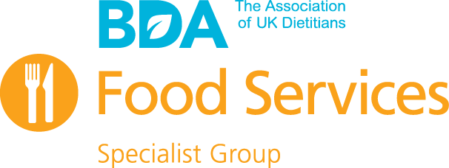
Annual General Meeting Minutes
The British Dietetic Association Food Services Specialist Group
Date and Time: Nov 24th 2021 at 3.30pm
Venue: Online Webinar
Present:
FSSG Committee:
Lauren Bowen (Chair), Ruth Smith (Minute-Taker), Saachi Avis, Maxine Cartz, Helen Ream, Leanne McDowell, Elise Kelly, Jo Instone, Emily Stuart, Rebecca Deeley, Rachel Liston, Amy Pratt, Megan Hughes.
FSSG Members:
Chantelle Brooks, Emily Fowkes, Angie Jefferson, Jayne Guppy, Kay Quirke, Alison Scott, Anne Donelan, Deborah Davison (nee Coleman), Julie Foster, Justine McGlinchey, Kushboo Naik, Heather Russell, Jo Greening, Sophie Rollings, Mandy Davies, Megan McClurg, Jilie Schreiber, Andrea Rymer, Vittoria Romano, Tom Dodd, Vivian Lopez, Vicki Pout, Katherine Crossfield, Elaine Lane, Helen Ord, Eirini Koutrouli, Tara Hargreaves, Charlotte Lloyd, Annabel Atkinson, Lorraine Holden, Angela Tella, Kate Taylor, Hannah Dobson, Sadaf Saied.

Number | Discussion
1 | Welcome, introductions and apologies  Meeting chaired by Ruth Smith, Secretary.  Apologies received from Annabel Atkinson and Eirini Koutroulis.
2 | Minutes of the previous meeting  The minutes of the meeting held Nov 26th 2020 were confirmed as a correct record. No amendments made.
3 | Matters arising from previous minutes  None
4 | Chair’s report.  - 2021 a challenging year with food supply and staffing challenges, and Natasha’s Law introduction  - Committee has formed working subgroups: The N&H Digest Review; Meetings & Webinar Planning; Web Promotion, Newsletter & Membership; Resources, Education & Training.  - New Student Role on Committee  - More active on Social Media, esp Twitter  - New active discussion forum on FSSG webpage  - New online format of monthly newsletter  - Committee member involvement in development of new Hospital Food and Drink Standards led by NHSE/I  - Committee member involvement in working subgroups established to progress the recommendations of the Independent Hospital Food Review  - Representation at the Parliamentary Food and Health Forum  - Committee members contributed to development of AHP Sustainability Plan  - Articles and lectures given to raise profile of food service dietetics as a career  - Representation on the IDDSI Reference Group (IRG)  - Supported NHS Chef of the Year competition  - Contributed to BDA response on National Food Strategy, Brexit, and Gov’s proposed Women’s Health Strategy  - Contributed to PENG Blended Diet/Enteral Feeding Toolkit  - Nutrition & Hydration Digest Update  - 2022 Commitments  - BDA Awards – Maxine Cartz Fellowship  - Thanks to all committee, members and Carlena
5 | Treasurer’s report  No major expenses this year as no face to face events. Main source of income are subscriptions. No deficit.
6 | Membership report  Included in Chair’s report
7 | Ratification of committee members  - Will Cook and Lisa Baker stepped down  - Sadaf Saied joined as PR & Web Comms Officer  - Megan Hughes changing role from PR & Web Comms Officer to Ordinary Member (as N&H Digest Chair)  - Rebecca Deeley & Rachel Liston changing roles from Ordinary Members to Co-Education & Training Officers  - Emily Stuart starting maternity leave  - Saachi Avis returning from maternity leave
8 | Any other business  None
9 | Meeting closed at 4pm

