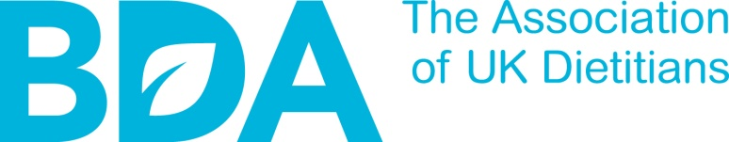

HM Revenue & Customs Address
Please write to your local tax office quoting your National Insurance number. You will find this information from your employer or you last P60 (if you are still with the same employer).

Dear Sirs

CLAIM UNDER SECTION 336 OF ITEPA 2003

I would like to make a claim for my professional subscription as a member of the British Dietetic Association. This claim applies to the following years.

MEMBERSHIP YEAR | FEE
2017/18 | £291.00
2018/19 | £298.20
2019/20 | £301.25
2020/21 | £304.26
2021/22 | £307.30

Please note that your subscription amount will vary depending on whether you paid by Direct Debit or card/cheque.

Please also add any Branches and Groups Subscription to this amount to show one figure per year.

I am able to clarify that I am able to claim as far back as the tax year 2017/2018, as I was a member a year before this time. I understand that this claim for 4 years is the maximum I can make and can also confirm that I have not claimed this amount previously.

I trust that you will apply my claim to my taxable income for each year and this will result in a refund which I would be grateful if you would send to my address above.

Many thanks for your assistance in this matter.

Yours faithfully

