IDDSI Frequently Asked Questions

- What is IDDSI?
The International Dysphagia Diet Standardisation Initiative (IDDSI) has published international standardised terminology and definitions for texture modified foods and thickened liquids for people with dysphagia. The framework consists of a continuum of eight levels (0-7) and includes descriptors, testing methods and evidence for both drink thickness and food texture levels. The framework aims to improve clinical safety and efficiency by offering healthcare providers standardised terminology to assist in the development of international collaborative clinical research and to standardise the terminology and consistency of different food providers in order to reduce risk.

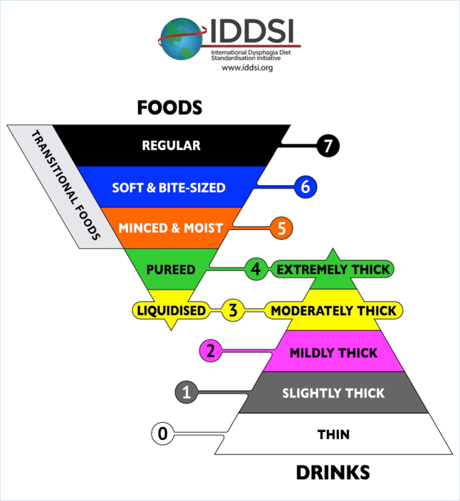

- How do I find out more about IDDSI?
The website www.iddsi.org offers comprehensive information about IDDSI. There will also be updates from the British Dietetic Association, The Royal College of Speech and Language Therapy and the companies producing commercial thickeners and texture modified meals will also be aware of any changes.

- There seems to be a big jump between Level 6 – Soft & Bite-sized and Level 7 – Regular. Why is this?

The IDDSI Framework has been developed to address safety for liquids and solids. For solids, both particle size and texture are important for reducing choking risk. Particle sizes have been chosen to reduce choking risk for both paediatric and adult populations (Brodsky et al., 1996; Litman et al., 2003). The other strategy that has been identified to reduce choking risk is the provision of mealtime supervision (Berzlanovich et al., 2005). Although all efforts are made to ensure adequate supervision, it cannot be assumed. The specifican that foods at Level 6 Soft & Bites-zed cannot exceed a maximum particle size dimension of 8mm x 8mm (paediatrics) and 1.5 x 1.5 cm (adults) is intended to address choking risk. For individuals who are NOT at risk of choking, who are independently able to cut or bite foods into appropriate sample sizes, and who do NOT need supervision or assistance while eating, then consideration should be given to prescribing a Level 7 – Regular diet, beginning with ‘soft options’ from this level. Regular diets contain many foods that are typically cooked and served to meet a soft texture requirement (e.g. items like lasagna, shepherd’s pie, risotto, paella are soft and moist, and do not have particle size restrictions).
References: Berzlanovich AM, Fazeny-Dorner B, Waldhoer T, and Fasching P. Foreign body asphyxia: A preventable cause of death in the elderly, American Journal of Preventive Medicine. 2005; 28, 65-69. Brodsky JB, Macario A, Mark JBD (1996) Tracheal diameter predicts double-lumen tube size: A method for selecting left double-lumen tubes. Anesthesia Analgesia, 82: 861-4. Litman RS, Weissend EE, Shibata D, Westesson P-L (2003). Developmental changes of laryngeal dimensions in unparalyzed, sedated children. Anesthesiology, 98(1): 41-45.

- Do I need to do the syringe test every time I make up a food/drink?
No you don’t have to do a syringe test every time. The syringe test offers a simple, user friendly gravity flow test to measure the flow of liquid. The IDDSI flow test has been developed to help categorise a wide range of liquids and to allow for quality checks and standardisation, it is not designed to be a bed side test.

- Do I have to implement IDDSI?
No, you do not have to implement the IDDSI. However, it is recommended that you do implement the IDDSI in your locality because manufacturers of dysphagia products (such as texture modified meals or thickeners) will be using the IDDSI terminology on their labelling. If you decide not to implement the IDDSI this may become confusing for your service users and potentially put them at risk. This may also cause difficulty when service users move between care settings/teams.

- What are the benefits of IDDSI compared to the UK Descriptors?
The benefits of using the IDDSI framework are fivefold:
- The framework has been developed after much research and collaboration across the world and each level is based on evidence. The current UK descriptors are based on a consensus of expert opinion not research evidence.
- The framework is a continuum and contains levels for fluids as well as foods. This means that the safety of patients when both eating and drinking is accounted for an d assured. Fluids are not included in the UK descriptors.
- The framework is being adopted across the world and countries currently implementing it include: USA, Australia, Canada, New Zealand, Germany and China to name but a few. This means that when healthcare workers and patients travel from country to country there will be no confusion about the dysphagia descriptors being used and this in turn means that patient safety is assured.
- If more countries use the same descriptors i.e. IDDSI then the ability to do larger research studies and systematic reviews is much greater and this means that we will be able to generate more robust evidence about the care of patients with dysphagia.
- The final benefit of implementing the IDDSI framework is that it gives professionals the opportunity to raise the profile of the care of patients with dysphagia.

- When will manufacturers implement IDDSI?

Manufacturers will be implementing IDDSI as from April 2018. However, it is likely to take several months for all the products and their labels to be changed over to the IDDSI descriptors. The changes will include changes to labelling as well as changes to the products so as to ensure product alignment with the new IDDSI framework. It is recommended that you contact your local manufacturers for further information about the timing of the introduction of IDDSI compliant products and foods in your local care setting.

- What is the deadline for implementation of IDDSI?
The aim is to have the IDDSI framework fully implemented in the UK by April 2019. We recommend that you do not start to implement IDDSI until April 2018 after which point dysphagia products (thickeners) and dysphagia specific foods produced by external manufacturers will start to become available locally. This gives you a whole year in which to implement IDDSI in your care setting. We estimate (based on trial evidence) that it will take 6 – 12 months to implement depending on the size if the care setting.

- What support will I get to implement IDDSI?
Implementation of IDDSI should be rolled out in a planned and coordinated way. An ‘Implementation Pack’ will be available by April 2018 which will contain checklists, posters, leaflets and training slides. These resources will be available to BDA members and non-members (including caterers, nurses, speech and language therapists) from the BDA website. The checklists will give you a list of activities that we suggest you do in order to implement IDDSI successfully. The commercial thickener companies will also be producing appropriate to support for the changes that are required for their products.

- Are the professional bodies aware of IDDSI?
The Royal College of Speech and Language Therapists and the British Dietetic Association have both undertaken a programme of work consulting with specialist practitioners to examine the framework and consulted with their respective professional membership. Both professional associations released statements in October 2017 to support adoption of the IDDSI framework in the UK:
BDA statement: https://www.bda.uk.com/news/view?id=186&x[0]=/news/list
RCSLT statement: https://www.rcslt.org/clinical_resources/dysphagia/dysphagia_diet

- What UK specific resources are available to help me implement IDDSI?
Work is underway to produce a resource pack / implementation pack to assist professionals to implement IDDSI in their care settings. The pack will contain:
- Implementation checklists
- A set of PowerPoint slides to aid training
- Posters to inform staff and patients about the IDDSI framework
- Posters to inform about the Flow Test
- Leaflets about IDDSI for patients
- Evaluation form
- A link to the IDDSI mobile app
The Implementation Pack will be available by April 2018 and will be accessible from the BDA website.

- Why not have dual labelling on dysphagia products?
The UK IDDSI group have agreed that dual labelling on manufacturer’s labels will not be part of the implementation process. Some initial trials looking at adopting the IDDSI guidelines found that dual labelling often caused confusion and a reluctance to change amongst healthcare professionals and patients. Between April 2018 and April 2019 manufacturers of dysphagia products and also caterers supplying texture modified diets will change their labelling over to IDDSI. During this initial phase they will also be able to provide support materials to help you in the changeover process; this may include posters/ leaflets explaining how the old descriptors translate into the new IDDSI levels.

- How do I implement this change in my hospital / nursing home?
Implementation of the IDDSI framework will require system change and it is therefore advisable for you to work with relevant managers and the multidisciplinary team within your establishment. The key to successful implementation is to set up a multidisciplinary implementation team including a dietitian, speech and language therapist, caterers and nurses. This team can then plan and execute the implementation process across your care setting – many hands make light work! The other keys to successful change programmes is communication prior to, during and after the change and of course training!
It is advised that you contact your local food, fluid thickener and food supplement suppliers to establish their timeframe for transition to the IDDSI framework and any support they may be able to offer. Similarly, you should consider the ongoing impact of transition to the IDDSI framework and develop documentation for individuals and relevant carers.
Checklists for assisting the implementation process in hospitals, nursing homes and the community will be available in early 2018 from the BDA website.

- Are there any examples of places that have implemented IDDSI already?
No UK sites have implemented IDDSI yet, however a pilot implementation has taken place in the UK at Leighton District General Hospital. Also, a pilot implementation project which has been written up and published was also undertaken in Germany. The details of this pilot can be found here: http://www.magonlinelibrary.com/doi/pdf/10.12968/bjnn.2017.13.Sup2.S18

The IDDSI website also contains examples of where IDDSI has been implemented across the world (http://iddsi.org/).

- What are the barriers to change that I am likely to meet and how do I overcome them?
The main barriers are likely to be the time to train staff, change menus and produce documentation for local use. Change is unsettling for staff. As with the implementation of any changes to care practices, there will be some staff who are reluctant to change and this is usually due to fear of the unknown and the anticipated pain of change. Because of this it is vital that you involve staff in the process early on and communicate, communicate, communicate. Working together in a coordinated way should help break down barriers. The posters, leaflets and training slides available in the ‘Implementation Pack’ will help you to communicate.

- Who should I involve to help me implement IDDSI?
Implementation is best done by a team of professionals depending on the care setting. We would advise that at a minimum the team should include:
- Dietitians
- Speech and Language Therapists
- Caterers
- Nurses
- Healthcare support workers
- Junior doctors
This multidisciplinary team ensures that all relevant staff are included in the process of implementation and feel a part of it – it also shares the work load and lessens the impact on one particular professional. We advise that this team would meet and devise a plan including at the beginning discussion with relevant senior and local managers. The team would also be responsible for the implementation and delivery of training, the provision of resources from the implementation pack (see Q. 10 for details)

- How long will it take to implement IDDSI?
The time is likely to vary depending on the size of the care setting that you work in but we estimate that it will take 6 – 12 months in total. We are able to base this estimate on evidence from a pilot in a medium sized hospital in Kempen, Germany. In this pilot, clear goal setting and timeline planning allowed for complete implementation to be achieved within 6 months of the decision to adopt the IDDSI framework.

- Are there any useful lessons in implementation from abroad?
Sharing best practice and learning from each other is vital. If you take a look at the IDDSI website you will find case studies on the implementation abroad and in the UK, alongside national implementation plans and resources which others have found helpful. The BDA and RCSLT will continue to share case studies and implementation support as we move towards adoption via the BDA website.

- How will I make sure that the safety of my patients is maintained during the implementation process?
You should utilise the same processes that you currently use to ensure the safety of your patients during the transition to the implementation stage. It is essential to ensure (through pertinent training and documentation) that all those responsible for the delivery of food, fluid and medication are aware of the prescribed modified food and fluid for each individual.

- What do I do if the manufacturers of dysphagia products (thickeners) have changed to IDDSI but the caterers haven’t?
It is important you work with all your suppliers to discuss their estimated timelines for changing to IDDSI. It is likely that the manufacturers of dysphagia products and caterers will have different timelines, in which case it may necessary to work with them to produce local guidance / information on how to compare both your current descriptors and the new IDDSI levels. This can then form part of your local implementation plan. Posters comparing the two sets of diet descriptors and leaflets will be available in the Implementation Pack. These posters will be a temporary measure until staff during the transition period and will also help to prevent confusion amongst staff and therefore help ensure patient safety.

- Can I set up IDDSI champions in my hospital / nursing home?
Yes. We would encourage you to designate one or more individuals as IDDSI or Dysphagia Champions. We would envisage that these Champions could act as key contact and information points during and after implementation. Care staff and patients can then ask the local Champion to clarify and advise on matters around IDDSI and dysphagia.

- Will care settings in all the UK nations including England, Wales, Scotland and Northern Ireland, have to implement IDDSI?
Yes, this is because IDDSI compliant dysphagia products and manufactured foods will start to become available in all of the UK nations as from April 2018. If any of the UK nations did not undertake an implementation programme in their care settings this would lead to confusion

amongst staff and patients alike and this could lead to patient safety problems. The implementation pack has been developed by a working group that includes professionals from all the UK nations. This has ensured that the resources are suitable for each nation.

- Evaluation: will I have to evaluate the implementation?
We would recommend you evaluate the implementation and to that effect we are developing a standardised evaluation tool to help you. The tool will help you to determine whether you need to do any more training or continue the communication process once you have implemented IDDSI. It will also tell you whether, as a consequence of implementing IDDSI, you have raised the profile/awareness of dysphagia as an important patient safety issue. We would also encourage you to send your evaluation results to us so that we can report on the success of the implementation form a whole country point of view.

- Who are the expert reference group that developed the implementation pack?
The team that developed the Implementation Pack included:
Dietitians, Speech and language therapists, representatives from the manufacturers of dysphagia products (e.g. thickeners), representatives for the catering companies and food producers, the National Association of Care Caterers, the Hospital Catering Association and representatives from nursing home companies.

