Nutritional support of Critically Ill Patients in Cork University Hospital during the Covid-19 outbreak.

March 2020

Contents:

1. Aim of document
2. Phases of management
3. Supervision and support
4. Benefits of nutrition in ITU
5. Guidelines for nutritional support
6. Important points kept simple – ventilation, fluid management, renal replacement therapy, obesity, non-nutritional source of energy.
7. Common drugs in ITU
8. Assessing ITU patient.
9. Frequently asked questions.
10. Appendix I : Modes of Ventilation
11. Appendix II: ITU algorithm for enteral feeding.

***Aim of Document:***

The provision of nutrition to critically ill patients is an intergral part of their care and its benefits have been well documented. We aim to enusure all patients receive appropriate nutrition support in the coming weeks in a variety of situations.

***Phase 1:*** Current ITU beds numbers.

1. Provision of Dietetic cover to continue as normal but will include training for Department of Nutrition and Dietetics.
2. Training in ICIP also will be provided.
3. During this phase the out of hours feeding policy may be extended to the working hours.

Training will be provided by:

Clare Twomey (Critical care)

Mary Dullea (Critical care)

Marie Sheahan (Parenteral nutrition/IF)

Gillian Dawson (Surgery/Intestinal Failure)

Aisling O’Grady (Critical Care)

Kate Murphy (Critical Care)

***Phase 2:*** Increase in patient numbers.

1. Provision of Dietetic cover will extend to all of Group 4 and other Dietitians (1 dietitian initially from each of the other groups). There will be ongoing Critical Care nutrition training.
2. We also propose a “Buddy System” where each Dietitan would have support from one or more ITU trained Dietitians.
3. The out of hours feeding policy will be extended to standard policy for commencing nutritional support.

4. Aim for Dietetic review within 3 days. Any concerns by medical/nursing staff can be addressed by contacting Lead Critical Care Dietitian on duty. Telephone: 086-8228385 087-6556867

***Phase 3:*** Increase in patient numbers or decrease in Dietitians due to illness.

1. Extension of cover to other Dietitians within the Department of Nutrition and Dietitians

2. Out of hours feeding policy is first line (see below)

3. Aim to review by day 3 if possible.

Supervision and Support:

All dietitians will be part of a group led by a Critical Care Dietitian who will provide ongoing education and support and back up.

**Nutritional Support:**

(Adapted from CCP, 2020)

During critical illness as part of the metabolic response, resting energy expenditure may be altered, leading to extensive catabolism, hyperglycaemia, and progressive lean body mass loss, changes in serum trace element levels, fluid retention, reduced synthesis of visceral protein. High prevalence of malnutrition in ITU population (40%). Catabolism combined with malnutrition can lead to several unwanted clinical sequelae.

* Impaired wound healing
* Impaired immune response
* Impaired coagulation capacity
* Impaired gut function
* Muscle wasting
* Reduced respiratory muscle function

Evidence suggests nutrition support can slow catabolism in ITU patients, cummulative calorie debt is associated with poorer outcomes.

ESPEN guidelines highlight the importance of recognising the different phases of critical illness when deciding route, timing and dose of nutritional support.

Early Acute Phase: e.g. days 1-2 characterised by metabolic instability and severe increases in catabolism.

Late Acute Phase: e.g days 3-7 defined by significant muscle wasting and stabilisation of metabolic disturbances.

Note: The duration of the early and late acute phase will differ from patient to patient.

Post-acute phase/late phase: Improvement and rehabilitation or persistent inflammatory/catabolic state and prolonged hospital stay. (Singer et al, 2018).

Goals of nutritional support in Critical illness is to provide nutrition support to those who need it, consistent with their medical condition, nutritional status, metabolic capability and available route of administration, while avoiding the adverse effects of under and overfeeding.

**Guidelines for Nutritional Support for Non ITU Dietitians:**

**Nutritional requirements based on ITU day – this is a very simplified guideline only. Penn State Equation (see below or download “Nutricia App”) can be used instead. This equation has been validated in >70% ITU patients but less reliable in low and very high BMI. Adapted from Intensive Care Nutrition Support Algorithm (Adults) Critical Care Programme (CCP) 2020.**

**Any issues contact Critical Care Dietitian on duty 086-8223235/087-6556867/Bleep 410**

|  |  |  |  |  |
| --- | --- | --- | --- | --- |
|  | **Days* in ICU** | **Kcal Goal** | **Protein Goal** | **Considerations** |
| **Early Acute** | 0-2 | ≤15-20  kcal/kg | ≤1g/kg | **Energy:**  Include non-nutritional energy sources (see below)  Consider refeeding syndrome risk.  Aim to meet full nutritional requirements but increase the rate slowly and this should result in reduced kcal provision in early few days.  **Protein:**  Use a higher protein feed such as Protein plus, Osmolite HP or Peptamen AF. |
| **Late Acute** | 2-7 | 20-25 kcal/kg | 1.3-1.5g/kg | **Energy:**  Include non-nutritional kcal sources (see below)  Consider refeeding syndrome risk.  Consider patients clinical status, more caution in patients who are sicker/not improving/deteriorating (aim lower energy target) compared to less caution in patients who are improving.  **Protein:**  Progressive increase to target. Aim for more protein in patients with losses i.e. 1.5-2g/kg (e.g. CRRT, wounds, steroids, high drain outputs, head injury, burns & trauma). Consider adding Prosource TF to meet needs.  Consider renal function if not on CRRT. |
| **Post-acute chronic phase** | 7+ | 25-30 kcal/kg | 1.5-2g/kg | **Energy:**  Progressive increase to target.  Monitor for signs of overfeeding.  **Protein:**  Aim for more protein in patients with losses (e.g. CRRT, wounds, steroids, high drain outputs).  Consider renal function if not on CRRT. |
| **Post-acute rehabilitation phase** | 7+ | 25-30+ kcal/kg | 1.5-2g/kg | **Energy:**  Monitor for overfeeding.  Consider activity level, amount and type of physiotherapy.  Monitor dry weight.  **Protein:**  Consider renal function if not on CRRT.  Consider activity level, amount and type of physiotherapy. |

1. ***Key:*** *CRRT – continuous renal replacement therapy;*

**IMPORTANT POINTS:**

**Ventilation:**

**Useful terms used in mechanical ventilation:**

FiO2: The % of inspired Oxygen

Tidal Volume: What volume of air (measured in cc) is being delivered.

Pressure Support: How much driving pressure the patient is receiving to assist inspiration.

Positive end expiratory pressure (PEEP): This is the pressure driven by the ventilator while the patient is exhaling and the minimum pressure the ventilator will provide. This pressure is to prevent the alveoli returning to atmospheric pressure during expiration.

See Appendix for explanations of different modes.

Prone ventilation has been used in this cohort with some success. This involves mechanically ventilating the patient when they are lying face down. The aim of which is to improve oxygenation. However this can prove difficult when attempting to meet nutritional requirements due to feeding intolerance.

Consider a concentrated feed while being proned (e.g. 16 hrs) and try and make up balance during the other hours. May not tolerate feed, restrictions with use of prokinetics due to cardiac issues. Consider low threshold for PN in this group.

**Fluid management:**

Arestrictive fluid management strategy is recommended. The aim is to reduce extravascular lung water. Where possible avoid “maintenance intravenous fluids, high volume enteral nutrition, and fluid bolus for hypotension. *Anzics Covid-19 Guidelines, 16 March 2020.*

If this is part of patient treatment consider using a 1.5 kcal or 2 kcal/ml feed e.g. Nutrison Concentrated.

**Renal replacement therapy:**

Dialysis used in CUH is continuous veno venous haemofiltration (CVVH) with citrate or heparin as the anticoagulant. There can be energy contributions from citrate and lactate but we are assuming this is negated by losses in the dialysate therefore energy requirements are calculated as above.

Protein requirements 1.5-2g/kg minimum.

Feeds used include Protein Plus, Osmolite HP and Peptamen AF with the addition of Prosource tf (Each sachet contains 45mls, 11g protein and 44 kcals per sachet). Fluid restriction nor usually an issue but in very unstable patients they may have difficulty removing fluid and may request a restriction.

Leave a regimen for OFF CVVH also. The most suitable regimen would be Nutrison Concentrated. Team can give extra fluids and electrolytes as required.

**Obesity:**

Energy: Aim for 11-14 kcals/kg actual body weight or 22-25 kcal/kg ideal body weight.

Protein: BMI >30kg/m2 aim for 2g/kg Ideal body weight

BMI: > 50kg/m2 aim 2.5g/kg ideal body weight

This can often be difficult to achieve practically – often use Osmolite HP or Peptamen AF with the addition of prosource tf.

|  |  |  |  |  |  |  |  |  |  |  |
| --- | --- | --- | --- | --- | --- | --- | --- | --- | --- | --- |
|  |  |  |  |  |  |  |  |  |  |  |
|  |  |  |  |  |  |  |  |  |  |  |

**Non nutritional sources of kcals:**

(A): Propofol: Administered in a lipid base 1.1kcals/kg. It is charted as mg/hr e.g. 100mg/hr.

You can check the volume on the flow sheet for past 24 hours at 7am.

Alternatively:

Propofol 1% divide by 10 to get the volume.

Propofol 2% divide by 20 to get the volume.

I.e. 100mg/hr 2% propofol = 100/20*24=*1.1=132 kcals

(B): Dextrose 5 % = 200 kcals /l

Dextrose 10 % = 400 kcals/l

Dextrose 50% = 2000 kcals/l

**Common drugs in ITU:**

All patients commenced on pabrinex, lactulose and senna (except post GI surgery).

*Adapted from Table 16.9. Drugs and nutrition in critical care (PENG)*

|  |  |
| --- | --- |
| Drug | Nutritional Consideration |
| Opioid analgesics/sedatives e.g. morphine, fentanyl | Can lead to decreased gut motility and therefore reduced gastric emptying – causing constipation, nausea and vomiting |
| Propofol (1 and 2%) | Energy source from lipid – 1.1 kcal/ml  Risks: fat overload & hyperlipidaemia. Request TG level if not already done. |
| Neuromuscular blocking agents e.g. vecuronium, atracurium | Lowers energy expenditure |
| Inotropes and vasopressors e.g. noradrenaline, adrenaline, dobutamine, vasopressin | Reduced perfusion (hepatic, renal & splanchnic)  Risk of gut ischaemia with high doses |
| IV fluids  e.g. crystalloids (0.9% NaCl, Hartman’s solution) , colloids( gelofusion, albumin) | Can contribute to Na overload  Can be a source of energy e.g. dextrose 200kcal/L 5% dextrose |
| Prokinetics  e.g. metoclopramide, erythromycin | Promote gut motility & gastric emptying |
| Phenytoin/rifampicin/ciprofloxacin | If given enterally – need break from EN to allow for drug absorption |
| Stress ulcer prophylaxis e.g. lansoprazole, omeprazole, ranitidine | Alters gastric pH – can make pH testing guided confirmation of NG tube placement unreliable |
| Citrate and glucose -based dialysis solutions | Source of energy ( see note above re CVVH] |
| Diuretics  e.g. furosemide, spironolactone (K sparing) | Risk of ↓K+,lo ↓Na, ↓Mg, ↑Na, & metabolic acidosis |
| Laxatives  e.g. Senna, lactulose | Can cause bloating, abdo distension & diarrhoea |
| Anti-diarrhoeal  e.g. codeine phosphate, loperamide | Can cause bloating, abdo cramps & constipation (if in excess)  Liquid anti-diarrhoeals may promote diarrhoea because of sorbitol |
| Antimicrobials  e.g. metronidazole, tazocin, gentamicin | Can cause changes to gut flora & diarrhoea |
| Insulin infusion | Risk of hypoglycaemia with feeding interruptions/breaks |

**Assessing the ITU patient – simple steps.**

1. Talk to the nurse.
2. Follow the Dietetic Assessment sheet.
3. What ITU day is it?
4. Has nutrition been commenced?
5. Check for refeeding?
6. Look at the biochemistry.
7. Are they on dialysis?
8. Is the patient ventilated?

What are their FiO2 requirements? In general the higher their requirements the more ventilatory support required. Ask the nurse if the ventilation requirements are high. Caution with energy provision.

1. Are they on inotropes? The higher the inotropes the more help the patient need to keep blood pressure up and organ perfusion. Monitor GI tolerance. Watch trends – good indicator of whether patient is getting better/worse.
2. Are they septic? Temp/WCC
3. Look at the trends – is the patient getting sicker/getting better or stable. Use this trend to dictate your approach.
4. Take a breath.
5. There will be a summary sheet at each patient’s bed with the important facts.
6. Ask the nurse or doctor.
7. Ring Critical Care Dietitian 086-8223235/087-6556867.

Frequently Asked Questions:

Questions: What are the contra-indications to enteral feeding in critical illness?

As per and ESPEN 2018 and EISCM guidelines EN is contra-indicated if:

* If uncontrolled shock/tissue perfusion goals not met.
* Uncontrolled/life threatening hypoxemia, hypercapnia or acidosis
* Active GI bleeding
* Overt bowel ischaemia.
* High output fistula (no access to do distal feeding).
* Abdominal compartment syndrome. (Intra-abdominal pressures are sometimes measured).
* GRVs >500ml/6hr

Question: What is an inotrope? Inotropes are a group of drugs that alter the contractility of the heart. Positive inotropes increase the contractility of the heart. Examples of inotropes include e.g. milrinone, epinephrine, norepinephrine, digoxin (weaker).

Question: What is a vasopressor? Vasopressor is a group of medications that increase vasoconstriction, the contractility off the blood vessels. Examples of vasopressors include epinephrine, norepinephrine, dopamine and vasopressin.

Question: Is it safe to feed a critically ill patient who is on a high dose of inotropes and high dose vasopressors?

Enterally feeding patients stimulates the blood supply to the gut.

As above guidelines suggest holding EN in the event of uncontrolled shock, or tissue perfusion goals are not being met, or if there is uncontrolled/life threatening hypoxemia, hypercapnia or acidosis.

When haemodynamically stable/ or in the case of stable hypoxemia, hypercapnia, or acidosis it is safe to commence feeding with caution.

Recent studies have shown it is safe to commence feeding in patients who are on high dose inotropes. Liaise closely with the consultant or medical registrar when commencing feeding in patients on high doses of inotropes. Consider starting at a low rate of feeding initially and gradually increasing EN, monitoring tolerance as the feed increases.

Question: What is trophic or trickle feeding? Trophic feeding is a term used to describe commencing an enteral feed at a low rate. It is defined as commencing at 20kcals/hr up to 500kcals/day.

There may be benefits of using trophic feeding in patients who do not tolerate full rate enteral feeding for example intestinal epithelial preservation, amplified brush border enzyme secretion, augmented immune function, and limited bacterial translocation.

Question: How does metabolism differ in critical illness?

The early acute phase of critical illness is characterised by haemodynamic instability which is followed by metabolic instability, and a period catabolism (irrespective of exogenous nutrient supply).

Metabolism is altered during critical illness with the aim of maintaining essential substrates for vital organs, rather than maintain muscle mass or fat stores. The neuroendocrine response to critical illness is marked by increased gluconeogenesis, glycogenolysis and insulin resistance. Critical illness has also been associated with mitochondrial dysfunction.

Over feeding protein in the early acute phase of critical illness may be linked to decreased autophagy (which is the body’s own ability to dispose of damaged cells), and therefore could potentially be harmful.

Question: Can I overfeed a critically ill patient?

In critical illness provision of exogenous nutrients does not suppress endogenous nutrient mobilisation, which is closely linked with insulin resistance. Therefore, it is possible to overfeed a critically ill patient, particularly in the early stages of critical illness.

Question: How will I know if I am overfeeding my critically ill patient?

Elevated blood glucose levels, elevated PCO2, elevated liver function tests, or elevated triglycerides may indicate that your patient is being overfed. If your patient is experiencing elevated levels of these parameters, and the cause is otherwise unknown, you should consider if you are overfeeding your patient.

Consider if you have accounted for all non-nutritional sources of energy, for example, propofol, dextrose, citrate, linezolid.

Consider if there have been any changes to the patient’s medical status that may warrant re-calculation of the patient’s nutritional requirements.

Questions: Do critically ill patients have decreased gut function and malabsorption?

GI dysmotility (delayed gastric emptying and altered intestinal contractility is common in critically ill patients and is exacerbated by fluid overload, intra-abdominal hypertension/compartment syndrome, ventilation, high dose catechoamines (i.e. inotropes e.g. epinephrine, norepinephrine, dobutamine, dopamine) and intravenous narcotics.

**Appendix I**

**Summary of Airway maintenance and ventilation:**

Remember the function of the lungs is gas exchange. This includes the transfer of oxygen from the air (or in this case artificial oxygen) to the blood, and also the removal of carbon dioxide (CO2) from the blood into the air. Gas exchange takes place in the alveoli of the lungs.

Cardiac function and circulation must be controlled or optimised to achieve adequate ventilation and stability in critically ill patients. Tissue perfusion which is the passage of blood through vessels to organs/tissue, and blood flow back to the heart and lungs play an important role.

**Optimising a patient’s own airway:**

Patients’ airway may become occluded by secretions, vomit, blood or a foreign body. Patients who are less conscious may have reduce muscle tone and may be unable to prevent their tongue from obstructing their own airway. Equipment can be used to help maintain their own airway. This is usually one of two type:

* Oropharyngeal: this is a hard-plastic tube that is inserted into the patient’s mouth to the oropharynx and prevents the tongue from moving. This method is used most frequently.
* Nasopharyngeal: this is a soft plastic tube that is inserted into the patient’s nostril to the pharynx. This is better tolerated in the semi-conscious patient.

**Endotracheal Intubation:** The creation of an artificial airway is sometimes necessary in critically ill patients. This is usually orotracheal. Indications for endotracheal intubation include

* Apnoea (temporarily stopping breathing) e.g. unconscious or severe respiratory distress.
* Respiratory failure: e.g. Acute Respiratory Distress Syndrome (ARDS) or pneumonia – endotracheal intubation required for mechanical ventilation.
* Airway obstruction: trauma, tumour, burns, laryngeal oedema
* Haemodynamic instability: e.g. cardiogenic shock or arrest – to facilitate mechanical ventilation.

**Modes of Mechanical Ventilation:**

Continuous Mandatory Ventilation (CMV): This ventilation provides a mandatory minimum minute ventilation, the volume is constant and there is a mandatory minimum number of breaths per minute.

Pressure Regulated Volume Control (PRVC): This ventilator mode combines a pressure limit with a volume assurance, thus ensuring a minimum minute ventilation.

Pressure support (PS):This ventilator mode assists the patient’s spontaneous breathing. The pressure support (which is the driving pressure given to assist inspiration) can be adjusted until the desired tidal volume is being achieved by the patient’s own breath. This mode if often used in when weaning a patient from a ventilator.

Synchronized intermittent mandatory ventilation (SIMV): The patient will get support for a pre-defined set number of breaths. If the number of breaths is more than the set number the patient will get no support for the additional breaths.

**Continuous Positive Airway Pressure (CPAP)** is the addition of a positive pressure to the expiratory side of the breathing circuit of a spontaneously breathing patient who may or may not be intubated. This sets the baseline upper airway pressure above that of atmospheric pressure, prevents alveolar collapse, and may recruit already collapse alveoli. Indications for CPAP include:

* hypoxaemia requiring high respiratory rate, effort and FiO2
* Left heart failure to improve hypoxaemia and cardiac output
* Weaning modality
* Reduces work of breathing in patients with high PEEP (used with caution and close monitoring).

**Non-invasive ventilation:**

Non-invasive ventilation is usually delivered via a facial mask or helmet. Some inspiratory support can be given via a mouthpiece.

Bi-level Positive Airway Pressure (BiPap): this support delivers adjustable levels of pressure support and PEEP. Deliver breaths can be either spontaneous or mandatory Some BiPAP devices are driven by air; to increase FiO2 supplemental O2 can be given.

Guidelines for Enteral Feeding

CUH ICU OCTOBER 2017

GI SURGICAL PATIENTS- only commence feeding as per surgical instruction and tolerate NG aspirates <250mls for these patients please

If commencing NG feeding without review by dietician refer to Out of Hours Feeding regime

Commence NGF at 20mls/hr

Consider NJ feeding, if NJT placement unsuccessful consider TPN

Replace 500mls & continue at 20mls/hr

Already on metoclopramide?

Replace 500ml

Decrease rate by 20ml/hr (minimum 20ml/hr)

Commence Erythromycin 250mg IV tds

Prokinetics - Daily review

Start and continue prokinetics if aspirates >250ml

Is Aspirate at 4hrs >500mls

Replace aspirate & increase rate by 20mls/hr

No yes

start metoclopramide 10mg IV tds

Is aspirate at 4hrs >500mls

Yes no

No yes

On metoclopramide >12hrs

Replace aspirate & increase by20mls/hr

Yes

Target reached?

Already on Erythromycin?

No

Aspirate 4hrly once stable on NGF

Yes

Yes

On Prokinetic

>24hrs

Yes

|  |  |  |  |  |  |  |  |  |  |
| --- | --- | --- | --- | --- | --- | --- | --- | --- | --- |
| ENTERAL FEEDING FLOW SHEET | | | | |  |  |  |  |  |
|  |  |  |  |  |  |  |  |  |  |
| **NUTRISON PROTEIN PLUS/PROTEIN PLUS MULTIFIBRE** | | | | | |  |  |  |  |
|  |  |  |  |  |  |  |  |  |  |
|  |  |  |  |  |  |  |  |  |  |
| VOLUME | 1000 | 1200 | 1300 | 1400 | 1500 | 1600 | 1700 | 1800 | 1900 |
| RATE | 42 | 50 | 54 | 58 | 63 | 67 | 71 | 75 | 79 |
| ***Kcals*** | ***1250*** | ***1500*** | ***1625*** | ***1750*** | ***1875*** | ***2000*** | ***2125*** | ***2250*** | ***2375*** |
| ***Protein*** | ***63*** | ***76*** | ***82*** | ***88*** | ***95*** | ***101*** | ***107*** | ***113*** | ***120*** |
| Sodium | 48 | 58 | 62 | 67 | 72 | 77 | 82 | 86 | 91 |
| Potassium | 43 | 52 | 56 | 60 | 65 | 69 | 73 | 77 | 82 |
| CHO | 142 | 170 | 185 | 199 | 213 | 227 | 241 | 256 | 270 |
| Fat | 49 | 59 | 64 | 69 | 74 | 78 | 83 | 88 | 93 |
| w/wo Fibre | 15 | 18 | 19.5 | 21 | 23 | 24 | 25.5 | 27 | 28.5 |
|  |  |  |  |  |  |  |  |  |  |
|  |  |  |  |  |  |  |  |  |  |
|  |  |  |  |  |  |  |  |  |  |
| **Nutrison protein plus with addition of Prosource TF** | | | | |  |  |  |  |  |
| 1 sachet | 1294/74 | 1544/87 | 1669/93 | 1794/99 | 1919/106 | 2044/112 | 2169/118 | 2294/124 |  |
| 2 sachets | 1338/85 | 1588/108 | 1713/104 | 1838/110 | 1963/117 | 2088/123 | 2213/129 | 2338/135 |  |
| 3 sachets | 1382/96 | 1632/119 | 1757/115 | 1882/121 | 2007/128 | 2132/134 | 2257/140 | 2382/146 |  |
| 4 sachets | 1426/107 | 1676/120 | 1801/126 | 1926/132 | 2051/139 | 2176/145 | 2301/151 | 2426.16 |  |
|  |  |  |  |  |  |  |  |  |  |
| **NUTRISON CONCENTRATED** | | |  |  |  |  |  |  |  |
|  |  |  |  |  |  |  |  |  |  |
| Volume | 600 | 700 | 750 | 800 | 900 | 1000 | 1200 |  |  |
| Rate | 25 | 29 | 31 | 33 | 38 | 42 | 50 |  |  |
| ***Kcals*** | ***1200*** | ***1400*** | ***1500*** | ***1600*** | ***1800*** | ***2000*** | ***2400*** |  |  |
| ***Protein*** | ***45*** | ***53*** | ***56*** | ***60*** | ***68*** | ***75*** | ***90*** |  |  |
| Sodium | 26 | 30 | 32 | 34.4 | 39 | 43 | 52 |  |  |
| Potassium | 27 | 32 | 34 | 36 | 41 | 45 | 54 |  |  |
| CHO | 120 | 140 | 150 | 160 | 180 | 200 | 240 |  |  |
| Fat | 60 | 70 | 75 | 80 | 90 | 100 | 120 |  |  |
|  |  |  |  |  |  |  |  |  |  |
| **Peptamen AF** | |  |  |  |  |  |  |  |  |
| Volume | 800 | 900 | 1000 | 1100 | 1200 | 1300 | 1400 | 1500 |  |
| RATE | 33 | 38 | 43 | 46 | 50 | 54 | 58 | 63 |  |
| ***Kcals*** | ***1200*** | ***1350*** | ***1500*** | ***1650*** | ***1800*** | ***1950*** | ***2100*** | ***2250*** |  |
| ***Protein*** | ***75*** | ***85*** | ***94*** | ***102*** | ***113*** | ***122*** | ***131*** | ***141*** |  |
| Sodium | 34 | 39 | 43 | 47 | 52 | 56 | 60 | 65 |  |
| Potassium | 46 | 52 | 58 | 64 | 70 | 75 | 81 | 87 |  |
|  |  |  |  |  |  |  |  |  |  |
| **Osmolite HP** | |  |  |  |  |  |  |  |  |
| Volume | 1000 | 1200 | 1300 | 1400 | 1500 | 1600 | 1700 | 1800 | 1900 |
| RATE | 42 | 50 | 54 | 58 | 63 | 67 | 71 | 75 | 79 |
| ***Kcals*** | ***1000*** | ***1200*** | ***1300*** | ***1400*** | ***1500*** | ***1600*** | ***1700*** | ***1800*** | ***1900*** |
| ***Protein*** | ***62.6*** | ***75*** | ***81*** | ***88*** | ***94*** | ***100*** | ***106*** | ***113*** | ***119*** |
| Sodium | 40 | 48 | 52 | 56 | 60 | 64 | 68 | 72 | 76 |
| Potassium | 51 | 61 | 66 | 71 | 77 | 82 | 87 | 92 | 97 |

TPN Flow sheet

|  |  |  |  |  |  |  |  |  |  |  |  |  |  |
| --- | --- | --- | --- | --- | --- | --- | --- | --- | --- | --- | --- | --- | --- |
| **TPN** | **Vol mls** | **ml/hr** | **Kcals** | **N2** | **Protein** | **Fat** | **CHO** | **Na** | **K** | **Ca** | **PO4** | **Mg** | **Zn** |
| **Kabi 11C** | 2302 | 96 | 2211 | 18 | 112.5 | 73 | 265 | 84 | 84 | 7 | 25 | 12.2 | 150 |
|  | 2000 | 83 | 1921 | 16 | 98 | 63 | 230 | 73 | 73 | 6.1 | 22 | 11 | 130 |
|  | 1800 | 75 | 1729 | 14 | 88 | 57 | 207 | 66 | 66 | 5.5 | 20 | 10 | 117 |
|  |  |  |  |  |  |  |  |  |  |  |  |  |  |
| **Kabi 9C** | 2056 | 86 | 1779 | 11.5 | 72 | 51 | 250 | 75 | 60 | 5 | 25 | 10 | 100 |
|  | 1700 | 71 | 1471 | 9.5 | 59.5 | 42.2 | 207 | 62 | 50 | 4 | 21 | 8 | 83 |
|  | 1500 | 63 | 1298 | 8.4 | 52 | 37 | 182 | 55 | 44 | 3.6 | 18.4 | 7.3 | 73 |
|  |  |  |  |  |  |  |  |  |  |  |  |  |  |
| **Kabi 18C** | 1500 | 63 | 2088 | 14 | 88 | 70 | 265 | 50 | 20 | 5 | 8 | 3 | 100 |
|  | 1200 | 50 | 1670 | 11 | 70 | 56 | 212 | 40 | 16 | 4 | 6 | 2 | 80 |
|  | 1000 | 42 | 1378 | 9 | 58 | 46 | 175 | 33 | 13 | 3 | 5 | 2 | 66 |
|  |  |  |  |  |  |  |  |  |  |  |  |  |  |
| **Kabi 12C** | 2000 | 83 | 1950 | 15 | 94 | 0 | 400 | 72 | 60 | 5 | 25 | 5 | 100 |
|  | 1800 | 75 | 1755 | 13.5 | 84.6 | 0 | 360 | 64.8 | 54 | 4.5 | 22.5 | 4.5 | 90 |
|  | 1600 | 67 | 1560 | 12 | 75.2 | 0 | 320 | 57.6 | 48 | 4 | 20 | 4 | 80 |
|  |  |  |  |  |  |  |  |  |  |  |  |  |  |
| **Kabi 8C** | 2000 | 83 | 1731 | 18 | 112.5 | 51 | 200 | 60 | 80 | 5 | 30 | 12 | 100 |
|  | 1800 | 75 | 1558 | 16.2 | 101.3 | 46 | 180 | 54 | 72 | 4.5 | 27 | 10.8 | 90 |
|  | 1600 | 67 | 1385 | 14.4 | 90 | 41 | 160 | 48 | 64 | 4 | 24 | 9.6 | 80 |

**ENTERAL FEEDING GUIDELINES FOR ADULTS IN GENERAL INTENSIVE CARE UNIT (CORK UNIVERSITY HOSPITAL)**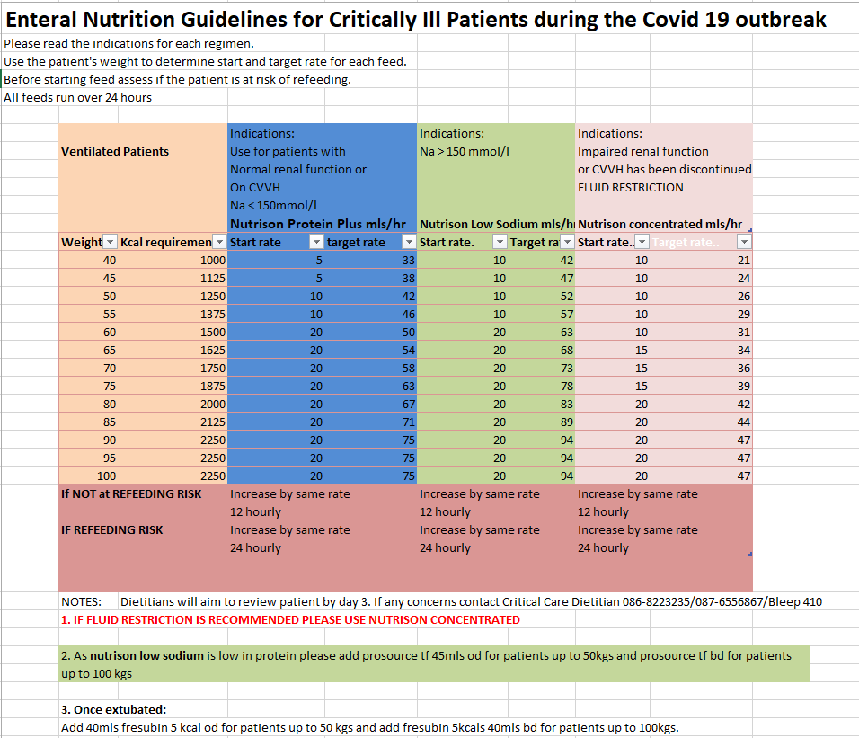

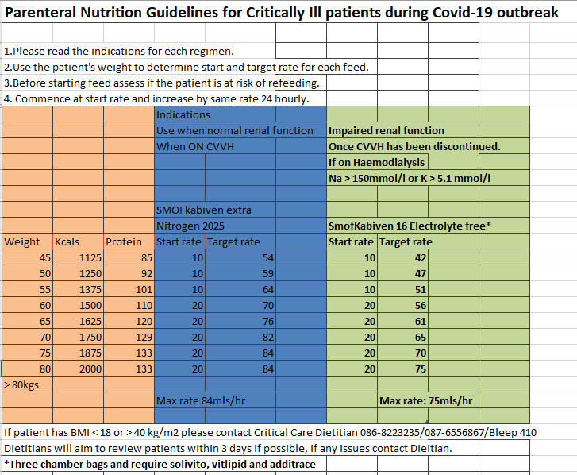

|  |  |  |  |  |  |  |
| --- | --- | --- | --- | --- | --- | --- |
| Enteral feeds | Kcals/100 ml | Protein/100 ml (grams) | CHO per 100ml (grams) | Na per 100mls (mmol) | K+ per 100mls  (mmol) | PO4 per 100mls  (mmol) |
| Nutrison Protein Plus | 125 | 6.3 | 14.2 | 4.8 | 4.3 | 2.9 |
| Nutrison Low Sodium | 100 | 4 | 12.3 | 1.1 | 3.8 | 2.3 |
| Nutrison Concentrated | 2 | 7.5 | 20.1 | 4.3 | 4.6 | 2.5 |

**Table 2 Nutritional Supplements**

|  |  |  |  |  |  |  |  |
| --- | --- | --- | --- | --- | --- | --- | --- |
| Nutritional Supplement | Product Description | Kcals | Protein (grams) | CHO (grams) | Na mmols | K+ mmols | PO4 mmols |
| Fortisip Compact Protein | Milkshake style  Flavours available: strawberry/vanilla  125mls  Suitable as a Grade fluid | 300 | 18 | 30.5 | 2.1 | 3.4 | 12.1 |
| Fresubin 5kcal  Quantities provided reflect 80mls total | Shot style supplement  Recommend 40mls dose (b.d.)  Liquid fat emulsion  Bottle size 120mls | 400 | 0 | 3.2 | Clinically insignificant amounts | Clinically insignificant amounts | Clinically insignificant amounts |
| Renilon 7.5 | High energy, low electrolyte, milkshake style supplement  For use in renal impairment  125mls bottle | 249 | 9.1 | 25 | 3.8 | 0.8 | 0.3 |
| Prosource TF  **Non oral supplement – for enteral tube administration only** | Tube administration only, not for oral consumption  Modular protein supplement  45mls sachet | 44 | 11 | 1 | 0.95 | 0.25 | 3.06 |

|  |  |  |  |  |  |  |  |  |  |
| --- | --- | --- | --- | --- | --- | --- | --- | --- | --- |
| Parenteral Nutrition | Volume (mls) | Kcals | Nitrogen (g) | Carbohydrate (g) | Na per (mmol) | K+ (mmol) | PO4  (mmol) | Additions required | Features |
| Kabi 8C PN | 2000 | 1731 | 18 | 200 | 60 | 80 | 30 |  | Suitable for patients with higher nitrogen needs not requiring fluid/electrolyte restriction |
| Kabi 18C PN | 1500 | 2088 | 14 | 265 | 50 | 20 | 7.7 |  | Lower electrolyte and lower volume bag |
| Smofkabiven 8 Electrolyte Free | 986 | 1100 | 8 | 125 | 0 | 0 | 0 | Additrace, Cernevit, Vitlipid | 3 chamber bag  Does not require refrigeration  Low volume, low nitrogen, low energy & electrolyte free bag  May need additional electrolyte supplementation  May require 2 bags in 24 hour period |
| Smofkabiven 16 | 1970 | 2200 | 16 | 250 | 80 | 60 | 25 | Additrace, Cernevit, Vitlipid | 3 chamber bag  Does not require refrigeration  For patients not requiring fluid/electrolyte restrictions |
| Smofkabiven Extra Nitrogen | 2025 | 1800 | 21.2 | 171 | 0 | 0 | 0 | Additrace, Cernevit, Vitlipid | 3 chamber bag  Does not require refrigeration  For patients with higher nutritional needs requiring electrolyte restriction |

**All bags are for administration via a central venous access device only**

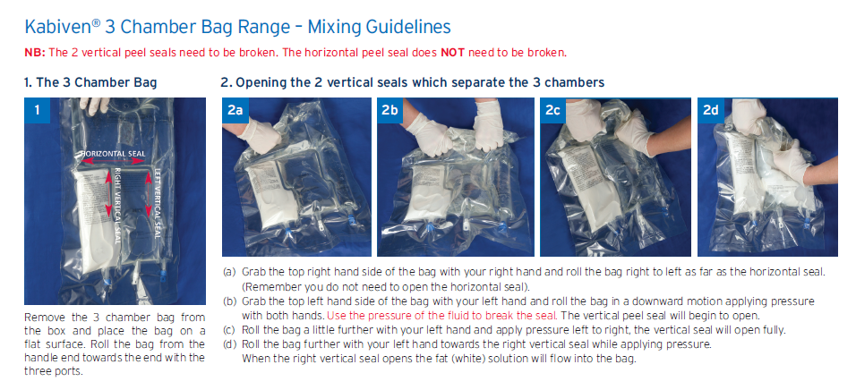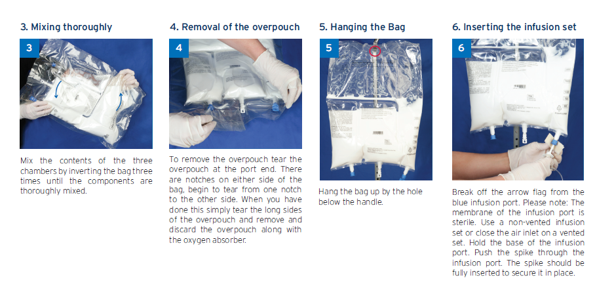

### 

### **Vitamin and trace element supplementation**

Certain regimens of PN, when recommended by the dietitian, will need a separate infusion of IV micronutrients. These infusions are documented by dieticians on the PN Prescription and Administration Record and are then prescribed by the medical team on the drug chart/Kardex.

* Solivito® – water soluble vitamins.
* Vitlipid® – fat soluble vitamins.
* Additrace® – trace elements.

Additrace N®, Solivito N® and Vitlipid N®, or a combination of these, may be added together to one 100mls bag of Glucose 5% or Sodium Chloride 0.9% and administered over 2-3 hours (allergy status should be checked prior to administration see CUH IV guideline/Monographs for further detailed information).